**INDEX:**

1. ***Cloud computing and vocabulary***
2. ***Principles of economic scales***
3. ***CapEx and OpEx , their differences***
4. ***Consumption based model***
5. ***IaaS vs PaaS vs SaaS cloud service models***
6. ***Public, Private and Hybrid cloud deployment models***
7. ***Geographies, Regions and availability zones***
8. ***Resources, Resource Groups and Resource manager***
9. ***Compute Services***
10. ***Networking Services***
11. ***Azure Storage services***
12. ***Database services***
13. ***Azure market place***
14. ***Azure IoT services***
15. ***Azure Big data and analytics Services***
16. ***Azure Artificial Intelligence(AI) Services***
17. ***Azure serverless computing services***
18. ***Azure DevOps solutions***
19. ***Azure tools***
20. ***Azure advisor***
21. ***Azure security groups***
22. ***User-defined Routes(UDR) with route tables***
23. ***Azure firewall***
24. ***Azure DDoS protection***
25. ***Azure identity services***
26. ***Azure security centre***
27. ***Azure key vault***
28. ***Azure role-based access control(RBAC)***
29. ***Azure resources locks***
30. ***Azure resource tags***
31. ***Azure policy***
32. ***Azure blueprints***
33. ***Cloud adoption framework for azure***
34. ***Core tenets of security ,privacy ,compliance***
35. ***Cost affecting factors***
36. ***Ost reduction methods ,reservations ,hybrid benefit ,Spot VM ,pricing and TCO***
37. ***Azure cost management***
38. ***SLA and composite SLA in Azure***
39. ***Service lifecycle in Azure***

# Cloud Computing and Vocabulary

**Cloud Computing**

Service delivery model over the internet (cloud). This includes but is not limited to

* **compute power** meaning servers such as windows, Linux, hosting environments, etc.
* **storage** like files and/or databases
* **networking** in azure but also outside when connecting to your company network
* **analytics** services for visualization and telemetry data

**Key concepts**

* **scalability** is the ability to scale, so allocate and deallocate resources at any time
* **elasticity** is the ability to scale dynamically
* **agility** is the ability to react fast (scale quickly)
* **fault tolerance** is the ability to maintain system uptime while physical and service component failures happen
* **disaster recovery** is the process and design principle which allows a system to recovers from natural or human induced disasters
* **high availability** is the agreed level of operational uptime for the system. It is a simple calculation of system uptime versus whole lifetime of the system.
  + availability = uptime/(uptime + downtime)

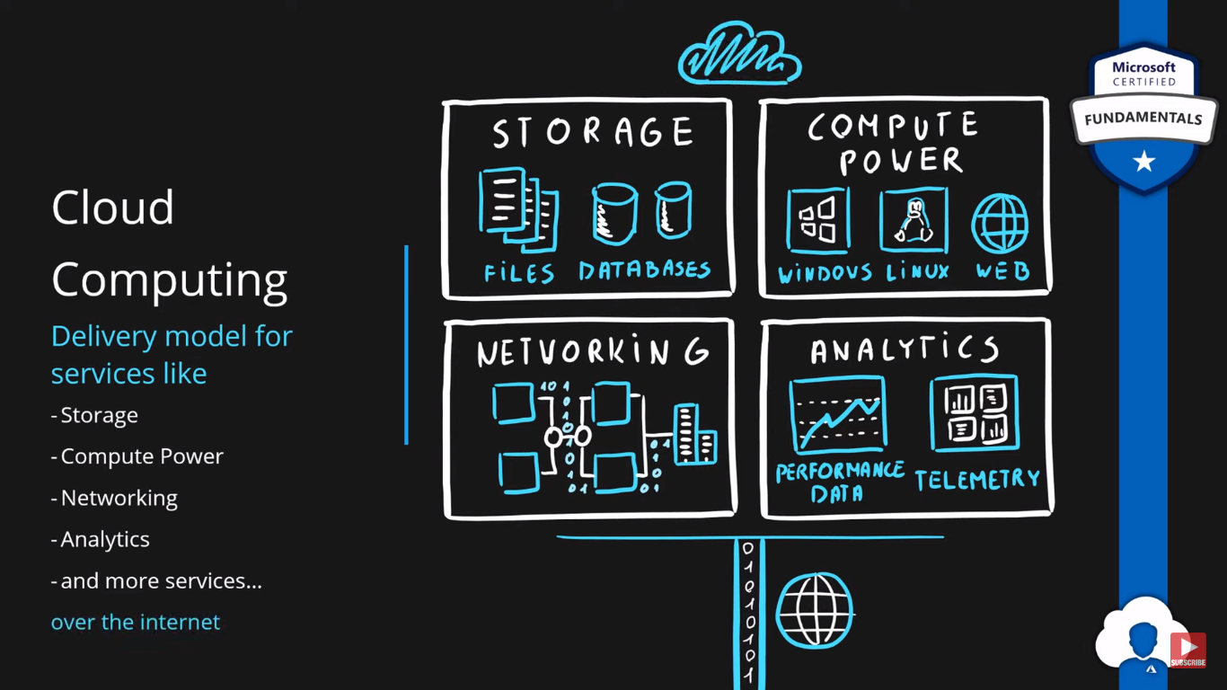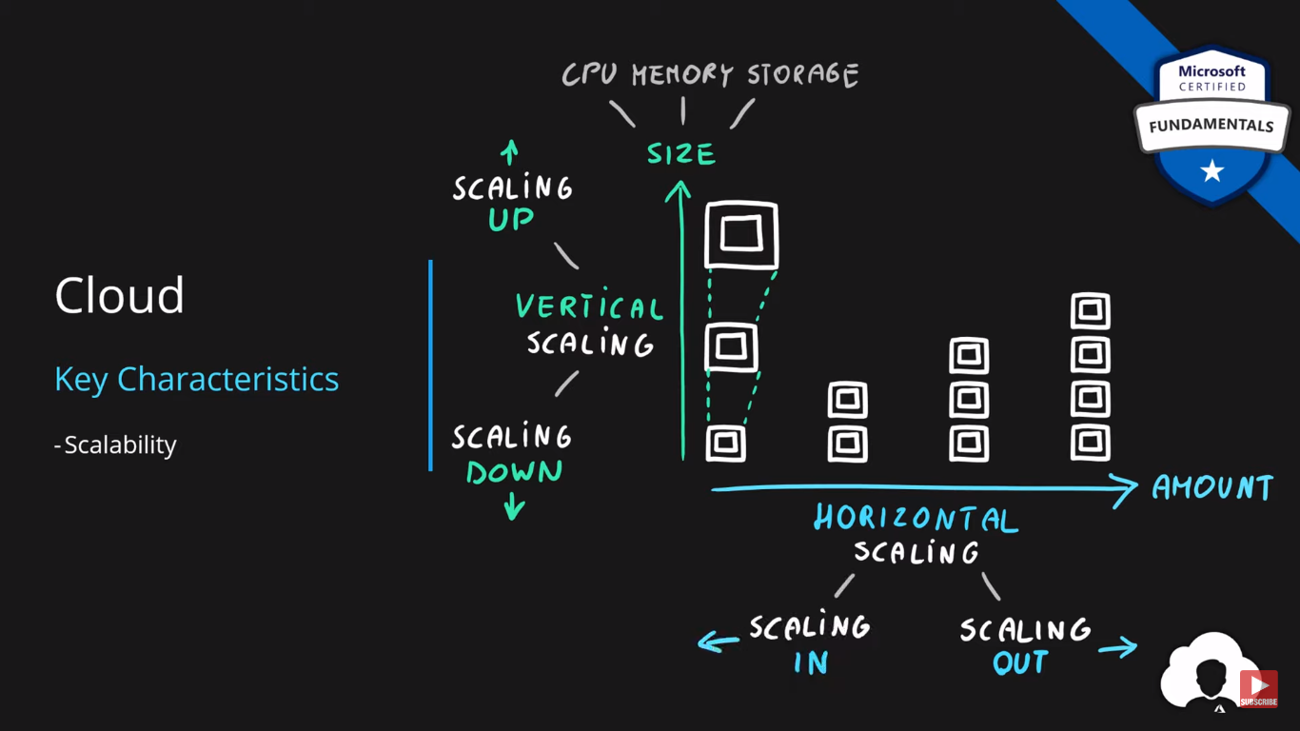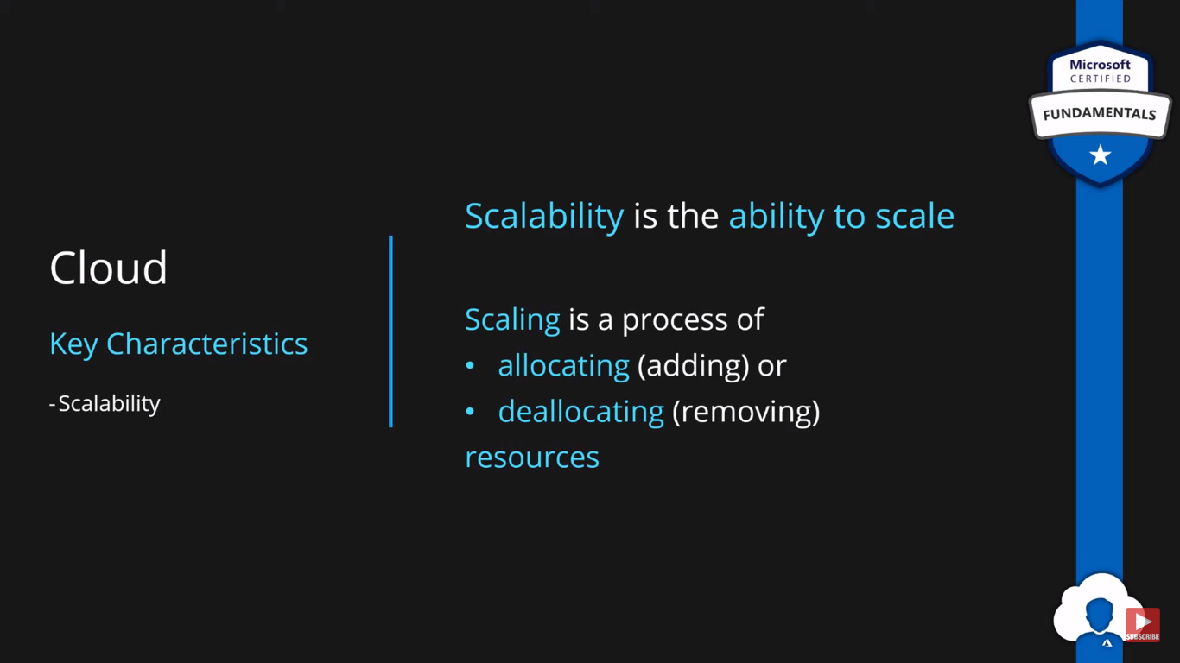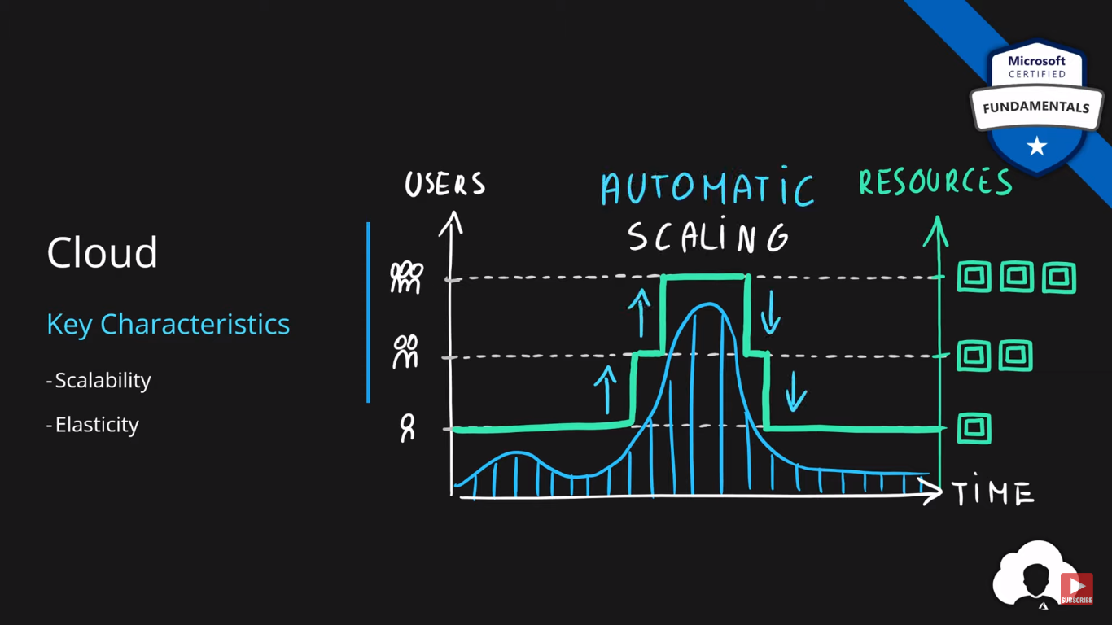

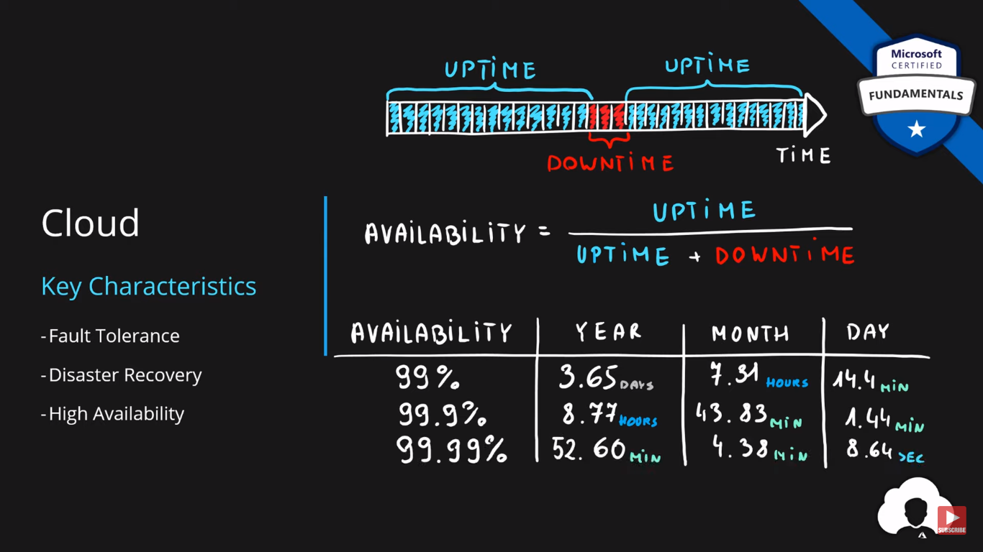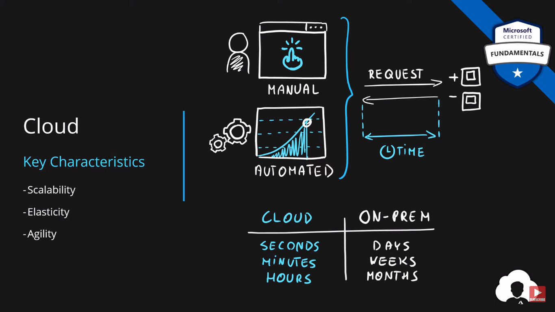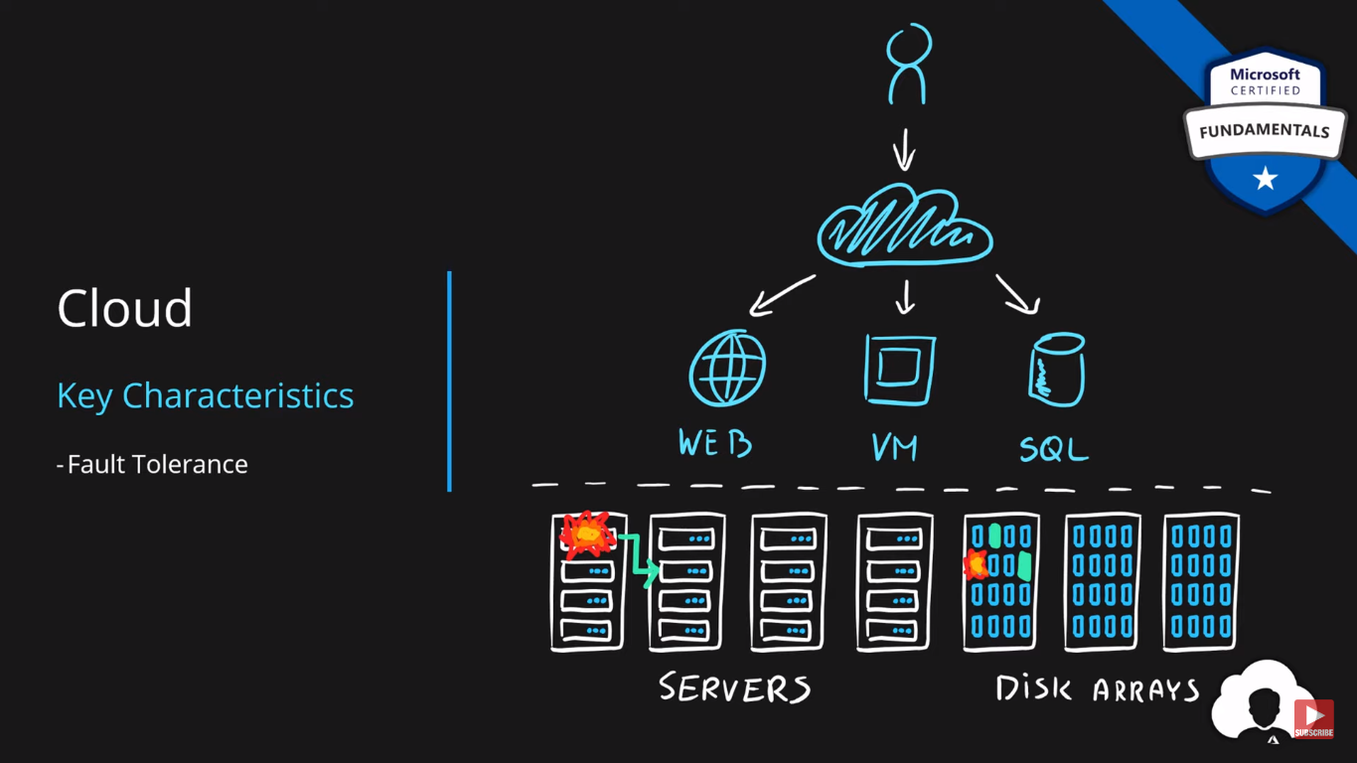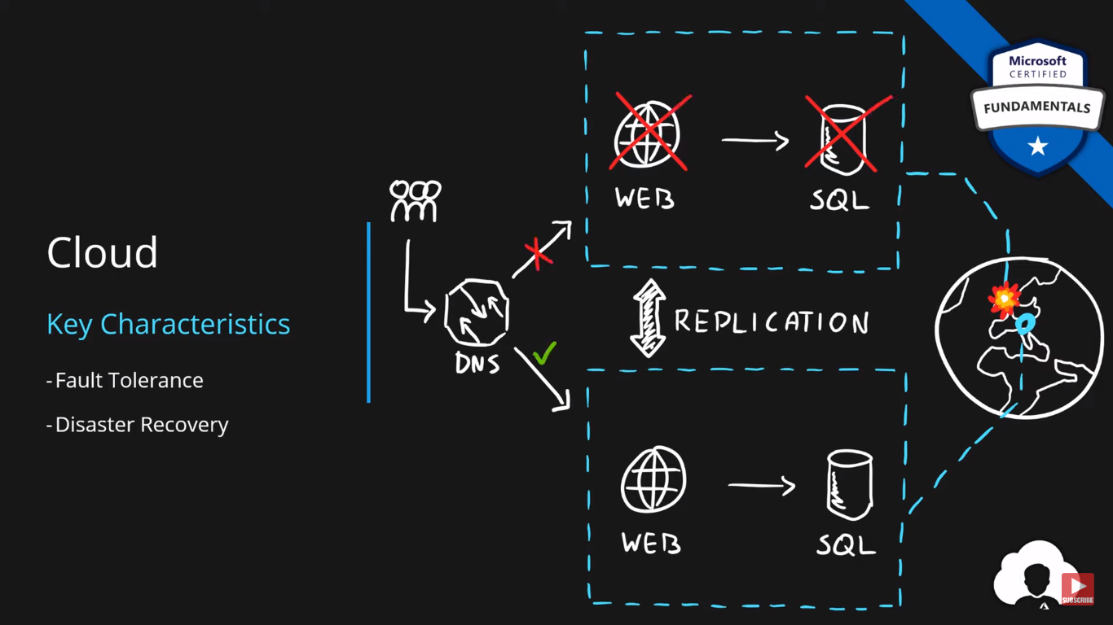

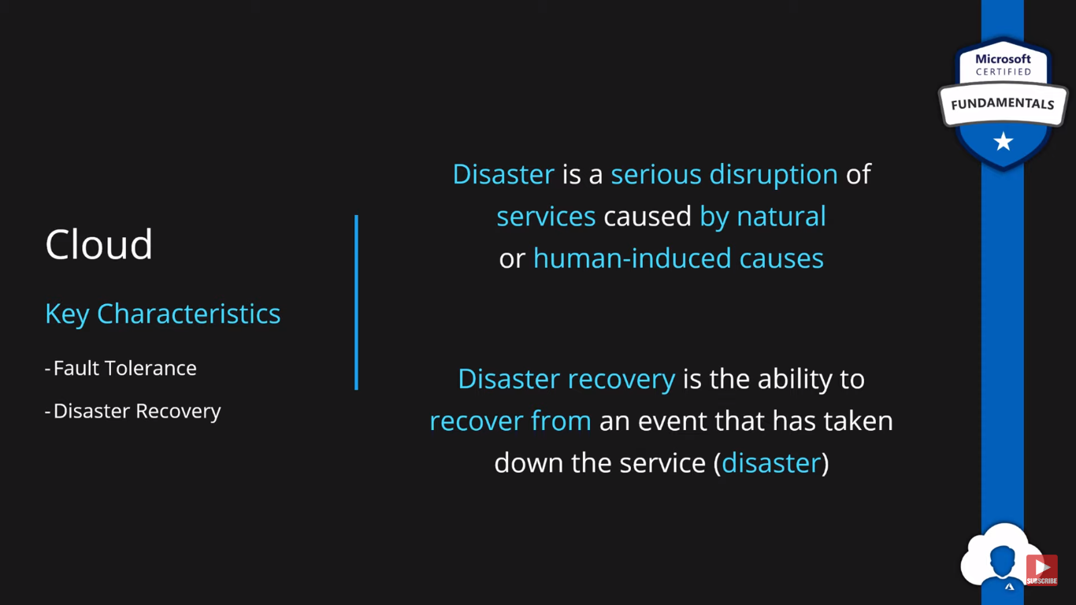

# Principle of economies of scale

The principle of economies of scale states that as the companies grow they become more effective at managing shared operations. Be that HR and hiring, taxes, accounting, internal operations, marketing, big purchases via contracts meaning better discounts, etc. etc.

Because of those, companies can save/earn more which in return allows for reduction in cost of their services to their customers. This is so called ‘price per unit.’

It’s not possible to go to 0 because in the end some underlying infrastructure needs to run to provide the services. But the larger the scale the more benefits can be passed to customers.

In fact, in the current scale, Microsoft can already offer multiple services for free due to how small a fraction of the cost it is for them.

# 

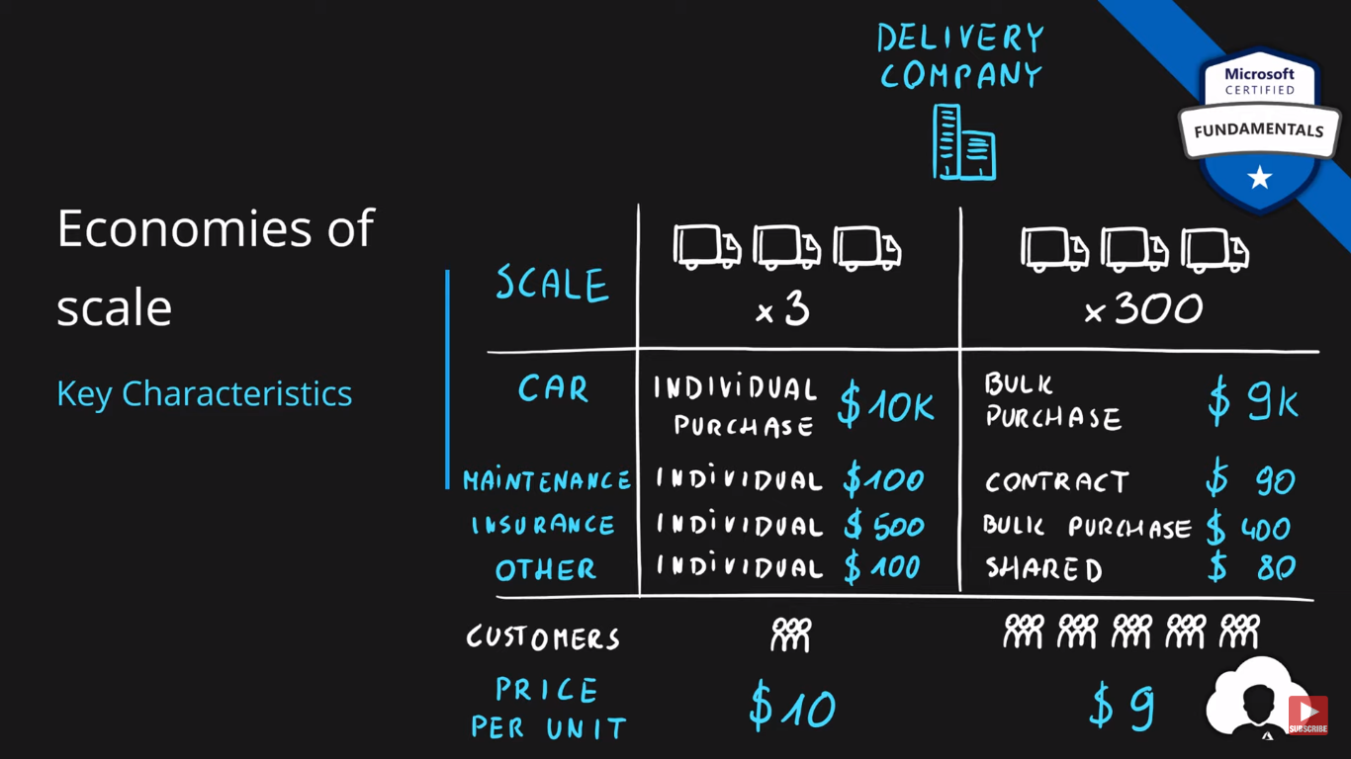

# CapEx vs OpEx and their differences

Differences between Capital Expenditure and Operational Expenditure

|  | Capital Expenditure | Operational Expenditure |
| --- | --- | --- |
| Up front cost | Significant | None |
| Ongoing cost | Low | Based on usage |
| Tax Deduction | Over time | Same year |
| Early Termination | No | Anytime |
| Maintenance | Significant | Low |
| Value over time | Lowers | No change |

# 

# Consumption-based Model

The consumption-based model is a **pricing model** used in the cloud so that customers are only charged **based on their resource usage**.

This model is characterized by

* **No associated upfront cost**
* **No wasted resources** as such no charges are incurred for unused resources*. Unused in this case is different per service. For instance, blob storage that stores any data is considered to be used, as it consumes the storage space. Virtual Machines that are running consume CPU, memory and other resources even if there isn’t any traffic. Hence they are considered to be used and will incur charges.
* **Pay for what you need**
* **Stop paying when you don’t**

**Consumption** is the virtual metric used to calculate how much each resource (service) in Azure was used. Each service has many smaller metrics that track its consumption to offer best possible pricing model. Those metrics are tracked on very granular level.

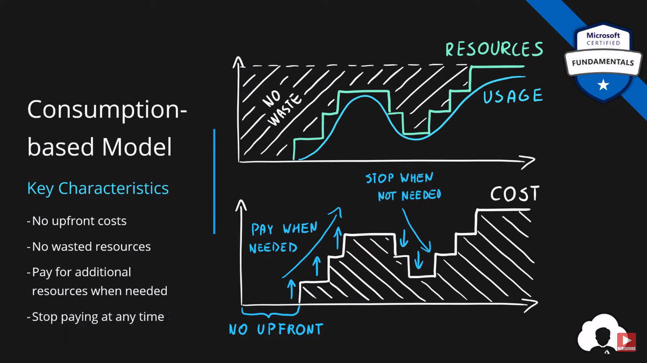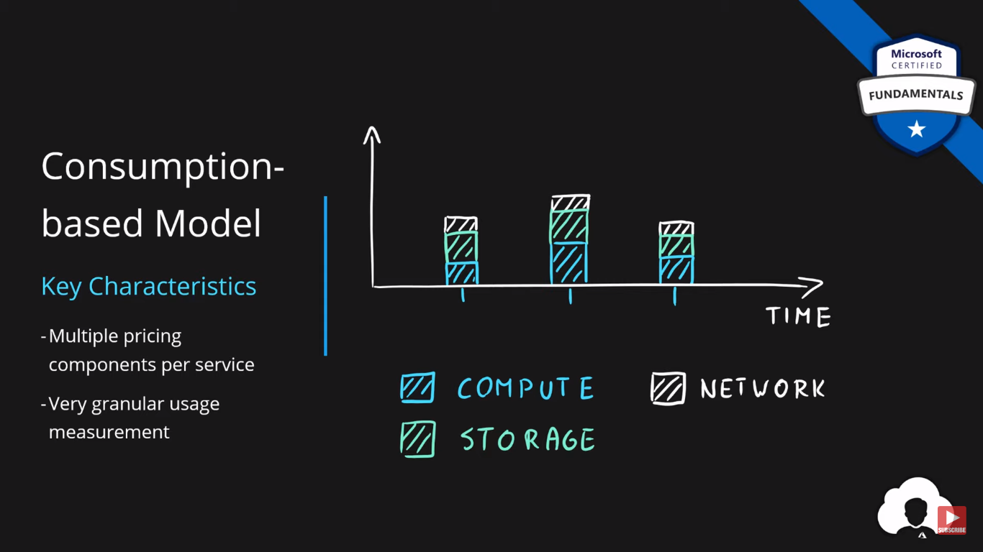

# IaaS vs PaaS vs SaaS cloud service models

| **Layer** | **Layer** |
| --- | --- |
| Application | Software |
| Data | Software |
| Runtime | Platform |
| Middleware | Platform |
| Operating System | Platform |
| Virtualization | Infrastructure |
| Servers | Infrastructure |
| Networking | Infrastructure |
| Storage | Infrastructure |

**As a service** means which party will manage the particular layer and all the layers below.

* **Software** layer consists the application (application code and set) & the application data
* **Platform** layer means all the supporting software and the operating system required to host the application
* **Infrastructure** layer consists hardware the infrastructure and virtualization required to host the platform

## **Responsibility Matrix**

As such following table represents responsibilities

| **Layer** | **On-Premises** | **IaaS** | **PaaS** | **SaaS** |
| --- | --- | --- | --- | --- |
| Application | You | You | You | Cloud provider |
| Data | You | You | You | Cloud provider |
| Runtime | You | You | Cloud provider | Cloud provider |
| Middleware | You | You | Cloud provider | Cloud provider |
| Operating System | You | You | Cloud provider | Cloud provider |
| Virtualization | You | Cloud provider | Cloud provider | Cloud provider |
| Servers | You | Cloud provider | Cloud provider | Cloud provider |
| Networking | You | Cloud provider | Cloud provider | Cloud provider |
| Storage | You | Cloud provider | Cloud provider | Cloud provider |

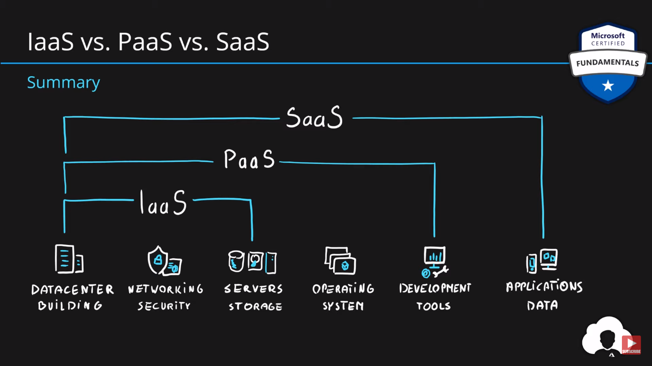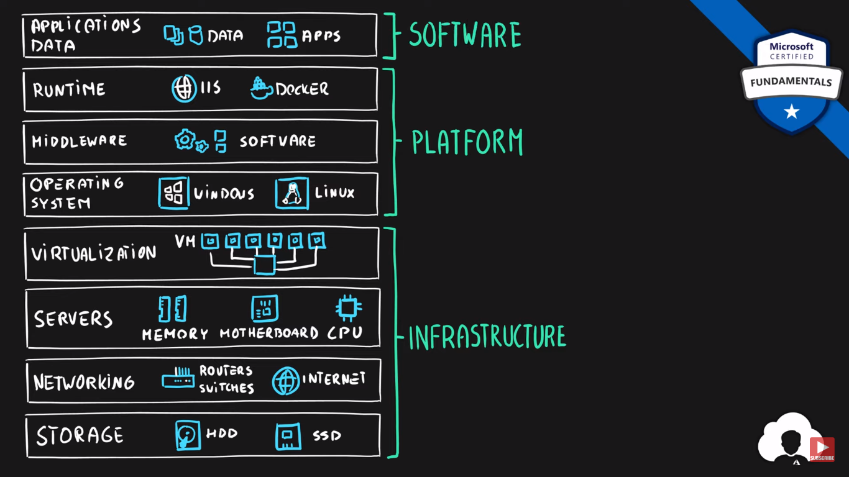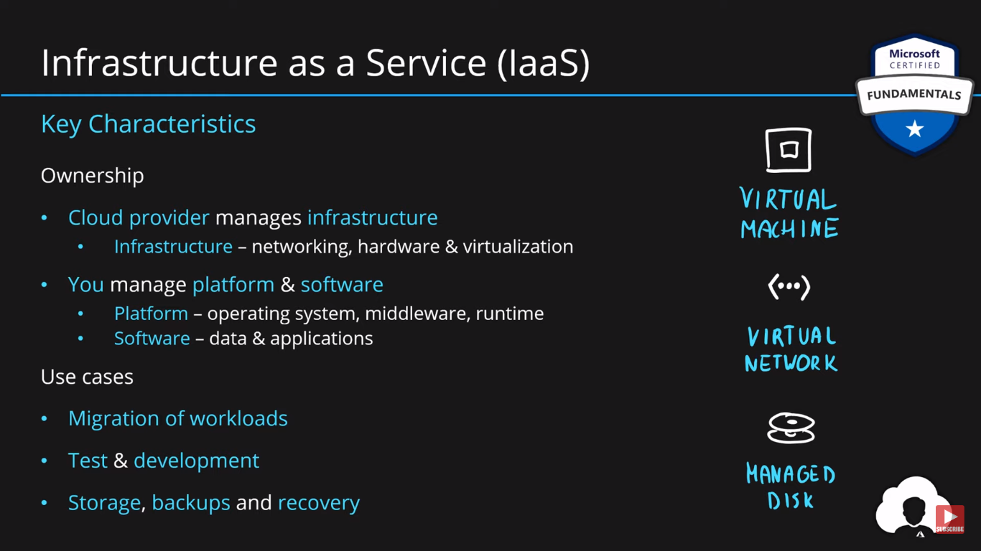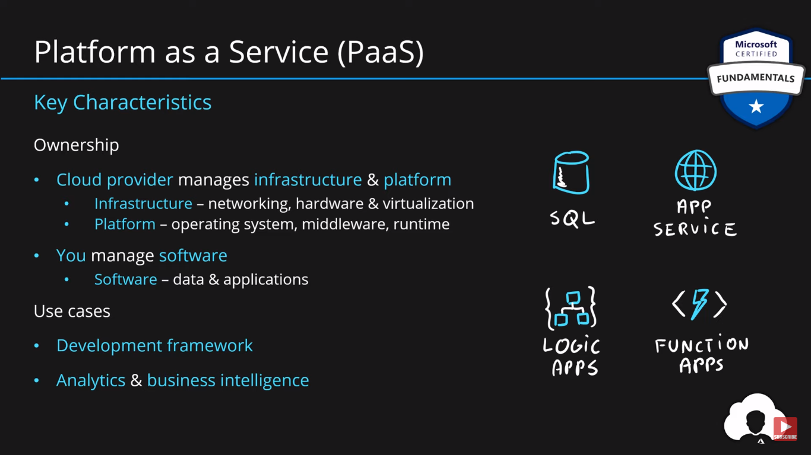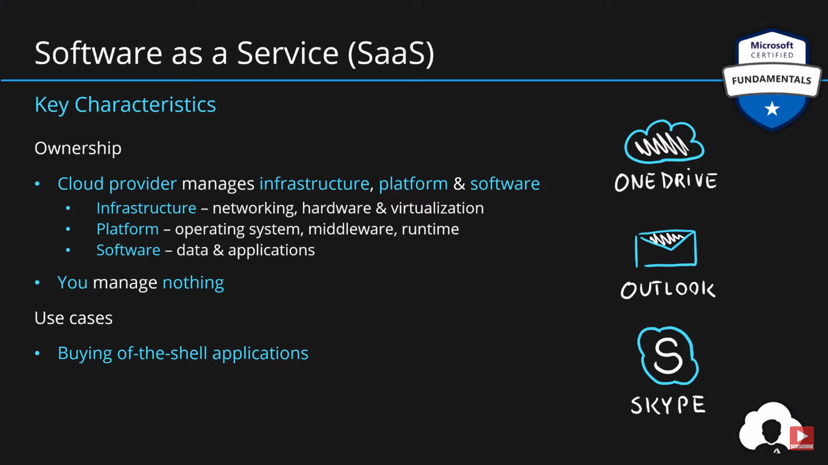

# Public, Private & Hybrid cloud deployment models

**Cloud Deployment Model** is simple a separation which describes where are the company resources deployed. Whenever this is in public cloud provider environment or private datacentre.

Below table presents high level deployment model separation

| **Layer** | **Cloud Provider** | **Own Datacentre** |
| --- | --- | --- |
| **Public** | ✅ | ✖ |
| **Hybrid** | ✅ | ✅ |
| **Private** | ✖ | ✅ |

## **Public Cloud**

| **Cloud Provider** | **Own Datacentre** |
| --- | --- |
| **✅** | **✖** |

**Key Characteristics**

* Everything runs on cloud provider hardware
* No local hardware
* Some services share hardware with other customers

**Advantages**

* No CapEx (No initial investment)
* High Availability
* Agility
* Pay as you Go (PAYG) pricing
* No hardware maintenance
* No deep technical skills required

**Disadvantages**

* Not all security and compliance policies can be met
* No ownership over the physical infrastructure
* Rare specific scenarios can’t be done

## **Private Cloud**

| **Cloud Provider** | **Own Datacentre** |
| --- | --- |
| **✖** | **✅** |

**Key Characteristics**

* Everything runs on your own datacentre
* Self-service should be provided
* You maintain the hardware

**Advantages**

* Can support any scenario
* Total control over security and infrastructure
* Can meet any security and compliance policy

**Disadvantages**

* Initial investment is required (CapEx)
* Limited agility constrained by server capacity and team skills
* Very dependent on IT skills & expertise

## **Hybrid Cloud**

| **Cloud Provider** | **Own Datacentre** |
| --- | --- |
| **✅** | **✅** |

**Key Characteristics**

* Combines both Public & Private cloud

**Advantages**

* Great flexibility
* You can run any legacy apps in private cloud
* Can utilize existing infrastructure
* Meet any security& compliance requirements
* Can take advantage of all public cloud benefits

**Disadvantages**

* Can be more expensive
* Complicated to manage due to larger landscape
* Most dependent on IT skills & expertise from all three models

# Geographies, Regions & Availability Zones

## **Data Centre**

* **Physical facility**
* **Hosting for** group of networked **servers**
* Own **power**, **cooling** & **networking** infrastructure

## **Region**

* **Geographical area** on the planet
* **One but usually more datacentres** connected with **low-latency network** (<2 milliseconds)
* **Location** for your services
* Some services are **available only in certain regions**
* Some services are **global services**, as such are not assigned/deployed in specific region
* Globally available with **50+ regions**
* Special **government regions** (US DoD Central, US Gov Virginia, etc.)
* Special **partnered regions** (China East, China North)

## **Availability Zone**

* **Regional feature**
* Grouping of **physically separate** facilities
* Designed to **protect from data centre failures**
* If zone goes down **others continue working**
* Two service **categories**
  + **Zonal** services (Virtual Machines, Disks, etc.)
  + **Zone-redundant** services (SQL, Storage, etc.)
* **Not** **all** regions are **supported**
* **Supported** region has **three or more zones**
* A **zone** is **one or more data centres**

**For finding the nearby data centres of azure -> Go for the speed test of azure Data centres using the following link**

* [Azure speed test](https://azurespeedtest.azurewebsites.net/)

## 

## **Region Pair**

* **Each region** is **paired** with another region making it a region pair
* Region **pairs are static** and cannot be chosen
* Each pair resides within the **same geography**\*
  + Exception is Brazil South
* **Physical isolation** with at least 300 miles distance (when possible)
* Some services have **platform-provided replication**
* **Planned updates** across the pairs
* **Data residency** maintained for disaster recovery

| **Region Pair A** | **Region Pair B** |
| --- | --- |
| East US | West US |
| UK West | UK South |
| North Europe (Ireland) | West Europe (Netherlands) |
| East Asia (Hong Kong) | Southeast Asia (Singapore) |

## **Geographies**

* **Discrete market**
* Typically **contains two or more regions**
* Ensures **data residency**, **sovereignty**, **resiliency**, and **compliance** requirements are met
* **Fault tolerant** to protect from region wide failures
* Broken up into areas
  + **Americas**,
  + **Europe**,
  + **Asia Pacific**,
  + **Middle** **East** and **Africa**
* Each **region belongs only to one Geography**

But not all the regions provides the entire azure services , it may vary from region to region . We can find those using the following link

* [Azure products by region](https://azure.microsoft.com/en-us/explore/global-infrastructure/products-by-region/?regions=non-regional,us-east,us-east-2,us-central,us-north-central,us-south-central,us-west-central,us-west,us-west-2,us-west-3,canada-east,canada-central,central-india,south-india,west-india&products=all)

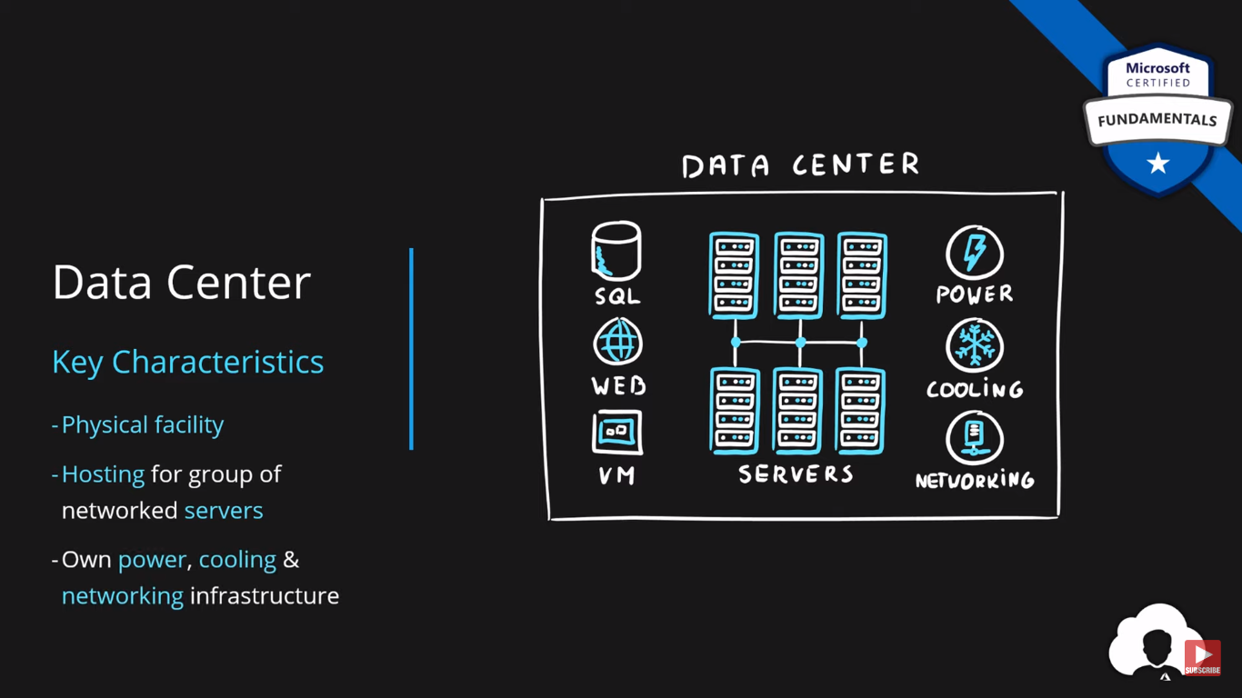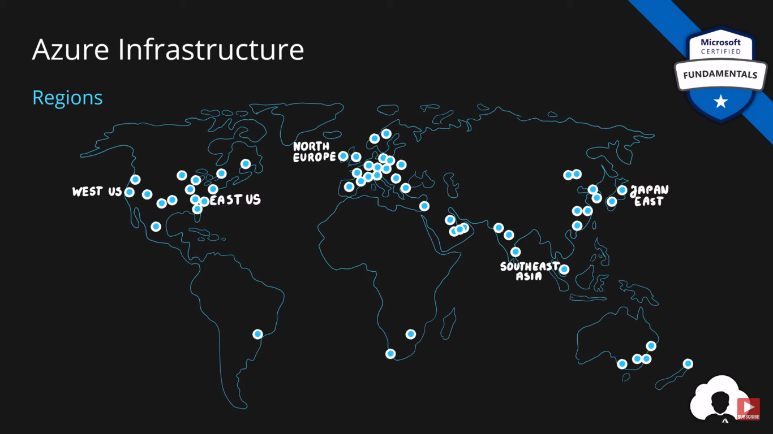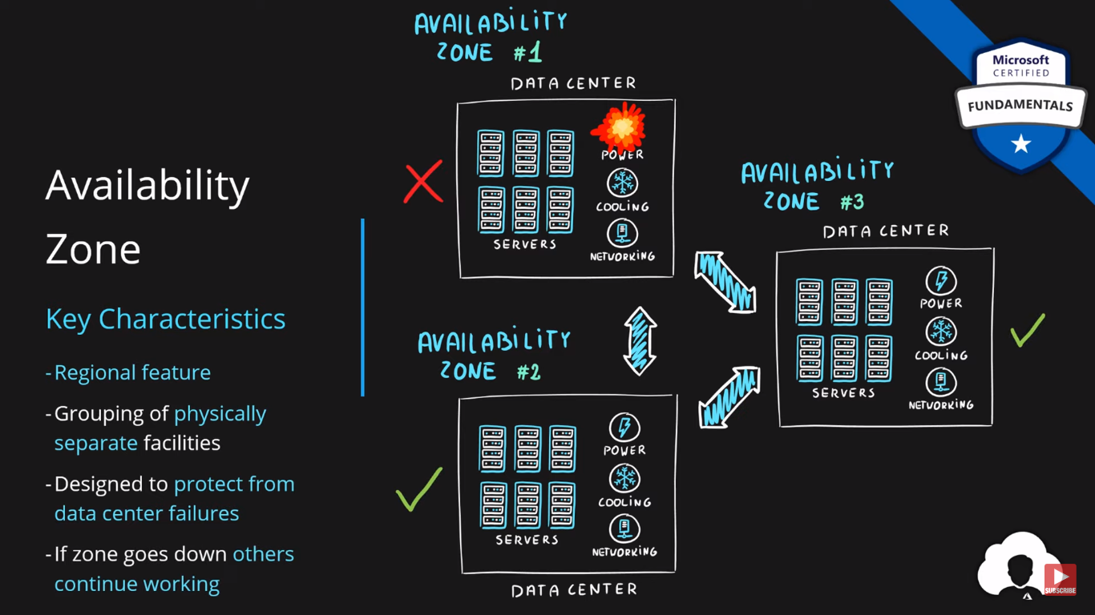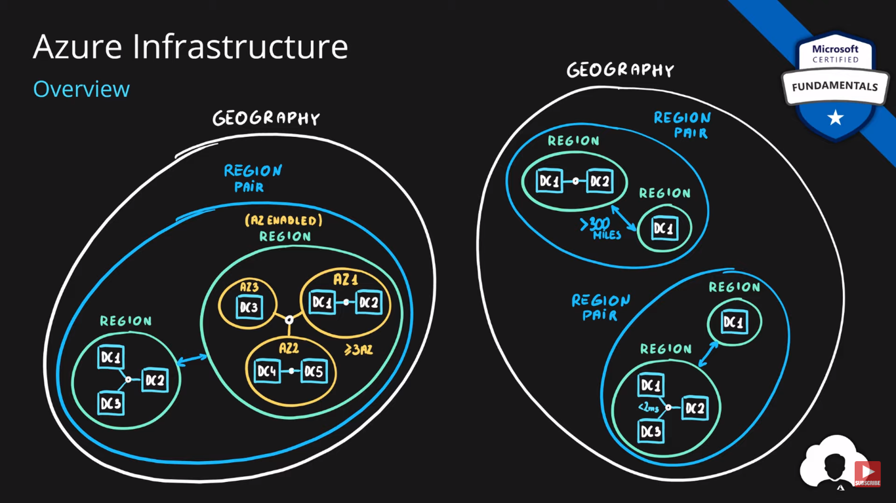

# Resources, Resource Groups & Resource Manager

## **Azure Resource**

* Object **used to manage services** in Azure
* Represents **service lifecycle**
* Saved as **JSON definition**

## **For creating the resource group**

Select the three-line icon 🡪Resource groups 🡪select the subscriptions 🡪set resource group name 🡪select location 🡪create a group

## **Then create the resource named storage account inside the resource group:**

Go to storage accounts 🡪 select the subscription and created resource group 🡪give name to the storage account and deploy it

To verify the list resources, we created got to the [Azure Resource Explorer](https://resources.azure.com/)

## 

## **Resource Groups**

* **Grouping** of resources
* Holds **logically related** resources
* Typically organizing by
  + **Type**
  + **Lifecycle** (app, environment)
  + **Department**
  + **Billing**,
  + **Location** or
  + **combination of those**

## **Resource Manager**

* **Management Layer** for all resources and resource groups
* **Unified** language
* **Controls** **access** and **resources**

### Additional Info

* Each **resource must** be in one, and **only one resource group**
* Resource **groups have their own location** assigned
* Resources in the resource groups **can reside in a different location**
* Resources **can be moved** between the resource groups
* Resource **groups can’t be nested**
* Organize based on your organization needs but consider
  + Billing
  + Security and access management
  + Application Lifecycle

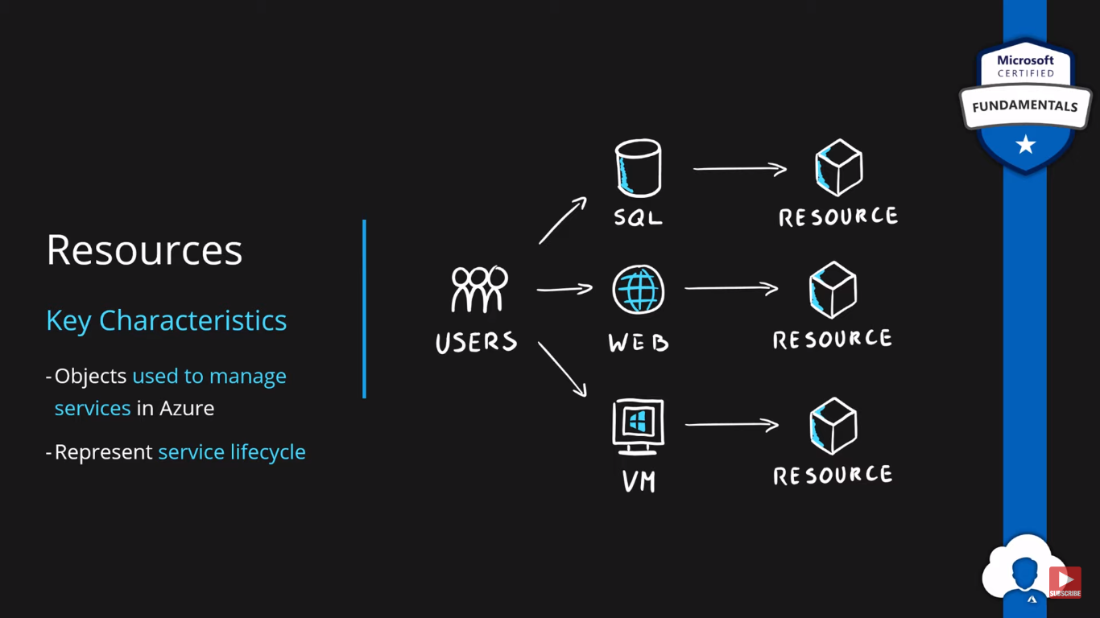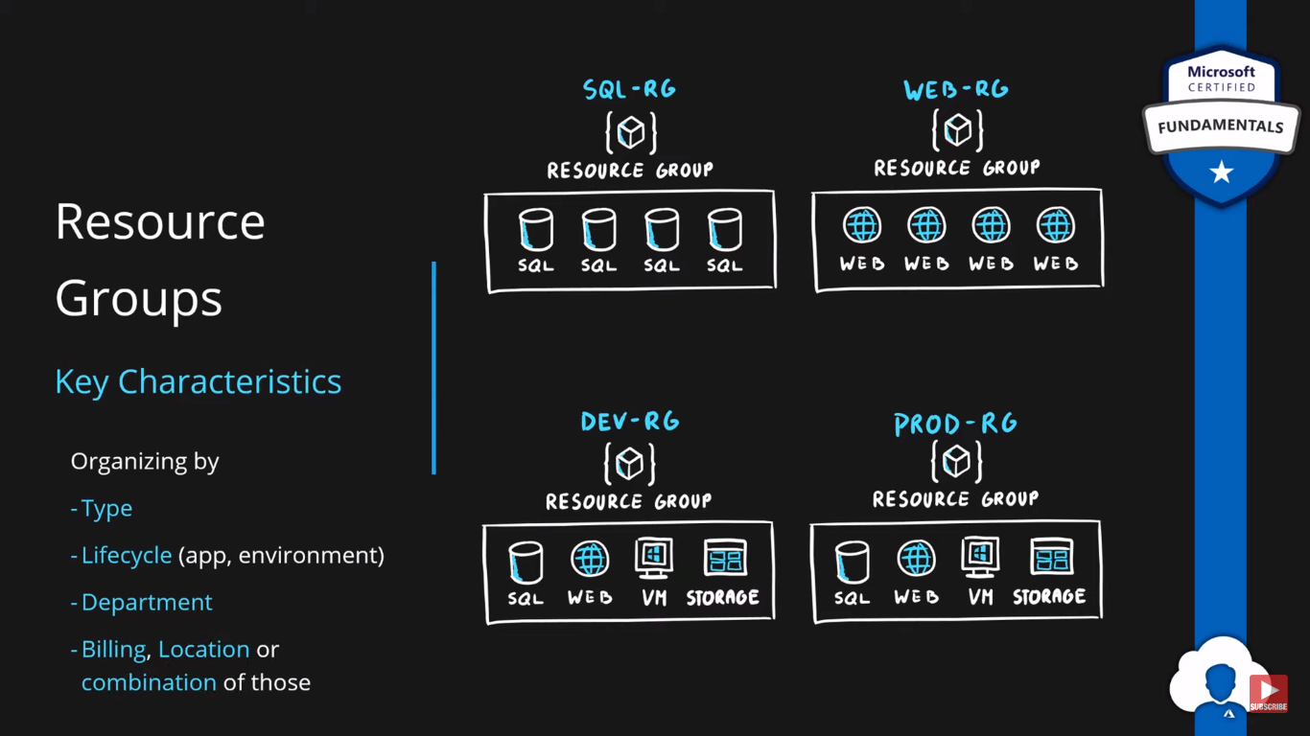

Using command prompt also we can access the azure services:

you need to install the Azure CLI and ensure its properly configured. Here are the general steps:

1. **Install Azure CLI:** You can download and install the Azure CLI from the official Microsoft documentation: [Install the Azure CLI](https://docs.microsoft.com/en-us/cli/azure/install-azure-cli)
2. **Add Azure CLI to the PATH:** During the installation process, there's usually an option to add Azure CLI to the system PATH. If you didn't choose this option during installation, you'll need to manually add the Azure CLI installation directory to your system PATH variable.
3. **Verify Installation:** After installation and updating the PATH, open a new command prompt window and type **az login** again to verify if the Azure CLI is recognized and working.

If you've already installed the Azure CLI but are still encountering issues, it's likely that the installation directory hasn't been added to the system PATH variable. You can manually add it by following these steps:

1. Right-click on "This PC" or "My Computer" and select "Properties".
2. In the System window, click on "Advanced system settings" on the left side.
3. In the System Properties window, click on the "Environment Variables..." button.
4. In the Environment Variables window, under System variables, find the "Path" variable and select it, then click on "Edit...".
5. In the Edit Environment Variable window, click on "New" and add the directory path where Azure CLI is installed (usually something like **C:\Program Files (x86)\Microsoft SDKs\Azure\CLI2\**).
6. Click "OK" in all windows to save your changes

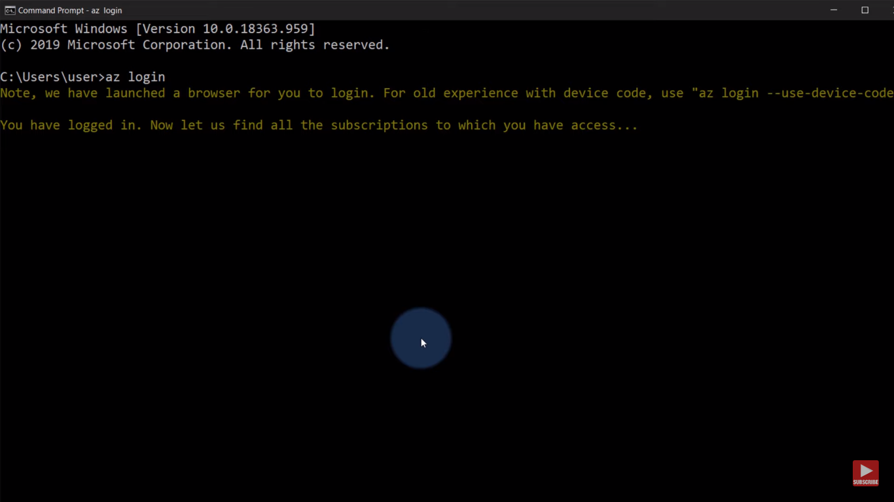

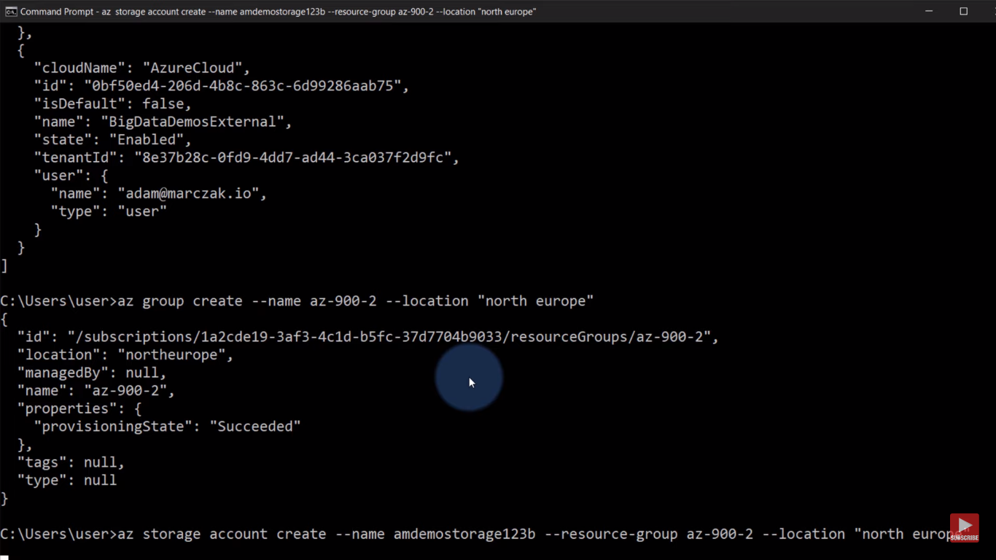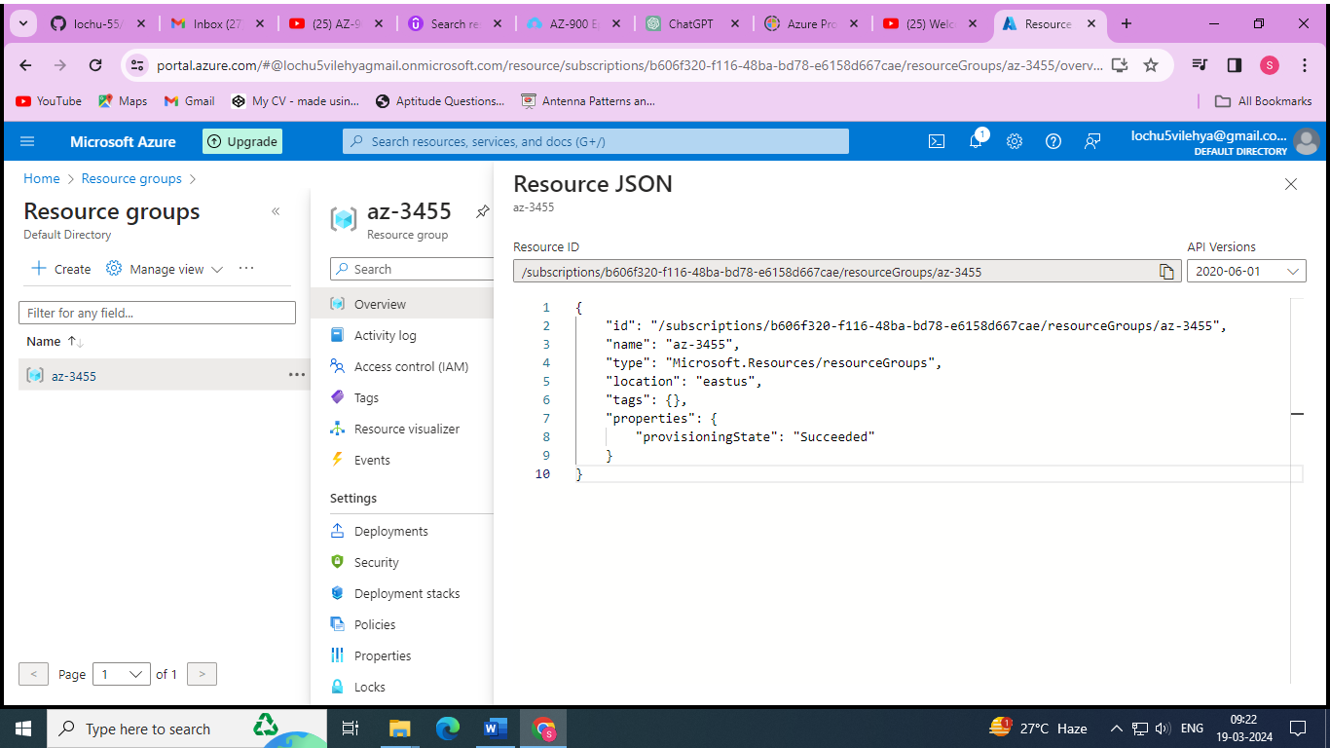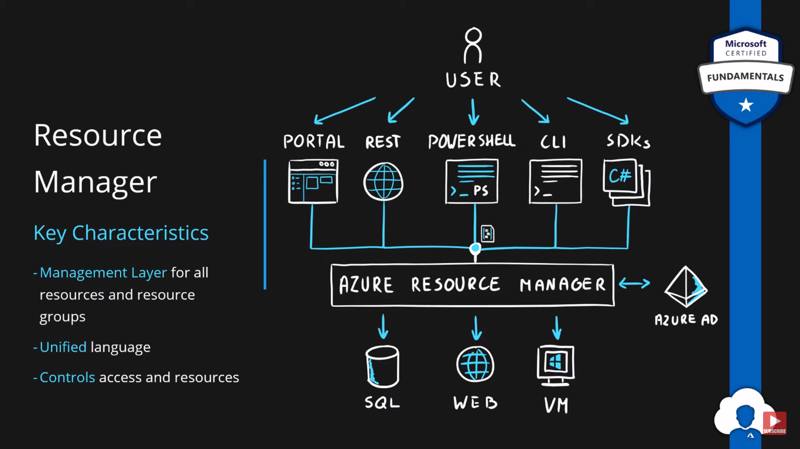

# Compute Services

### Virtualization

* Emulation of physical machines
* Different virtual hardware configuration per machine/app
* Different operating systems per machine/app
* Total separation of environments
  + file systems,
  + services,
  + ports,
  + middleware,
  + configuration

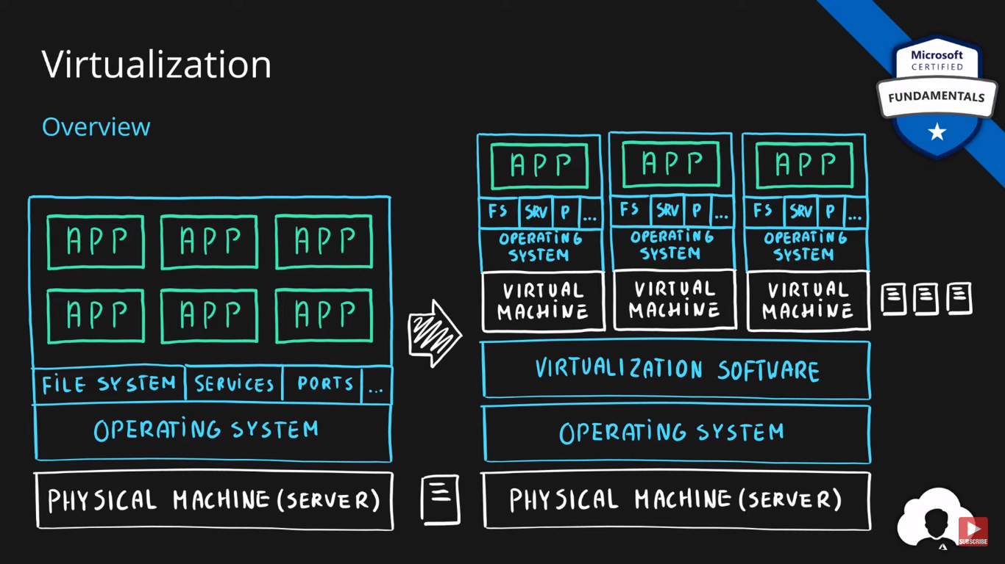

## **Virtual Machines**

* Infrastructure as a Service (IaaS)
* Total control over the operating system and the software
* Supports marketplace and custom images
* Best suited for
  + Custom software requiring custom system configuration
  + Lift-and-shift scenarios
* Can run any application/scenario
  + web apps & web services,
  + databases,
  + desktop applications,
  + jump boxes,
  + gateways, etc.

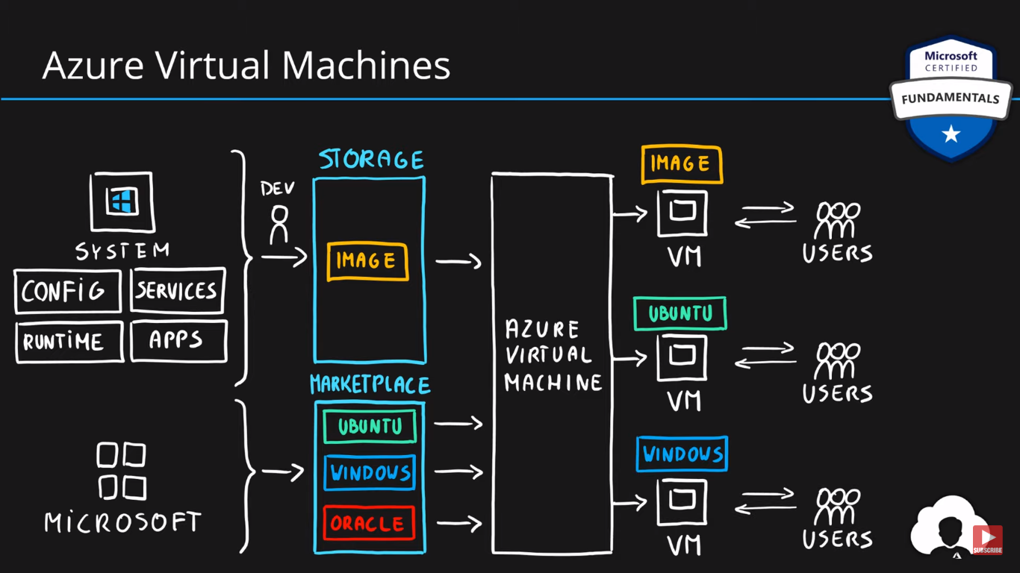

## **Virtual Machine Scale Sets**

* Infrastructure as a Service (IaaS)
* Set of identical virtual machines
* Built-in auto scaling features
* Designed for manual and auto-scaled workloads like web services,* batch processing, etc.

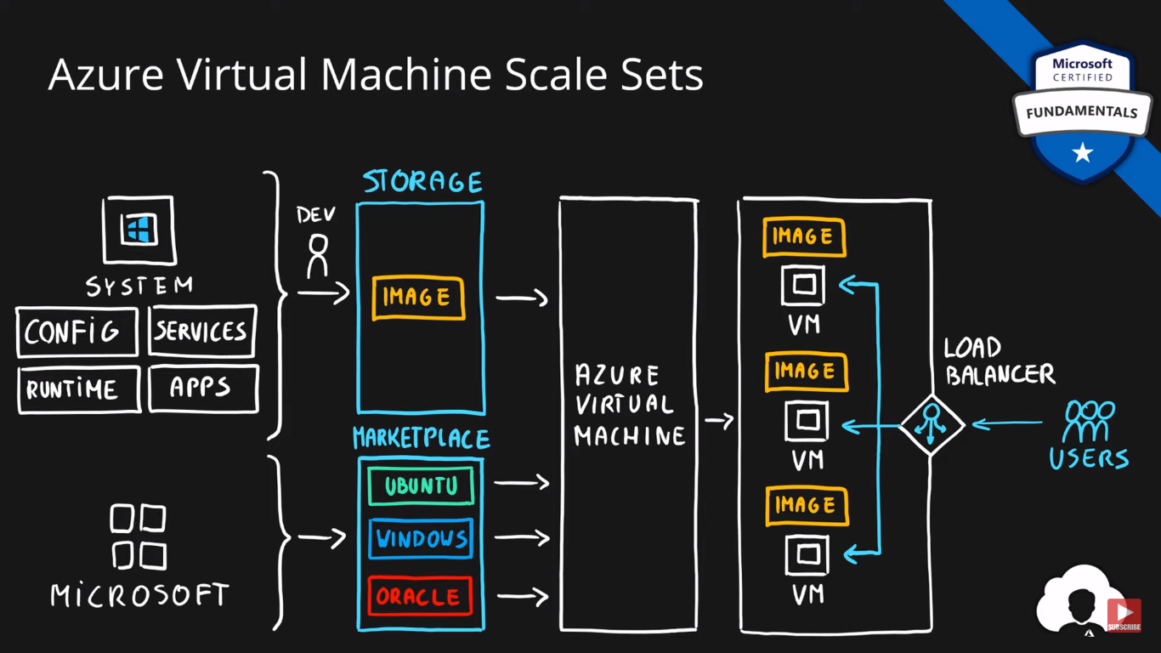

### Containers

* Use host’s operating system
* Emulate operating system (VMs emulate hardware)
* Lightweight (no O/S)
  + Development Effort
  + Maintenance
  + Compute & storage requirements
* Respond quicker to demand changes
* Designed for almost any scenario

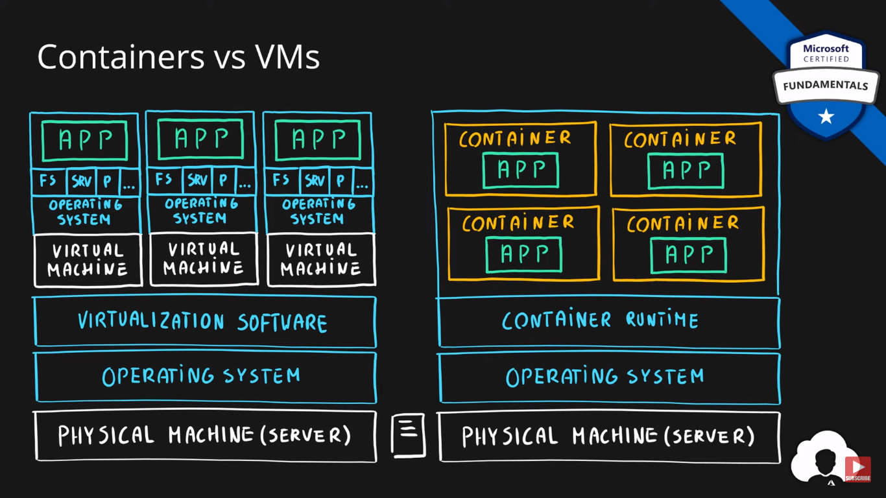

## **Azure Container Instances**

* Simplest and fastest way to run a container in Azure
* Platform as a Service
* Serverless Containers
* Designed for
  + Small and simple web apps/services
  + Background jobs
  + Scheduled scripts

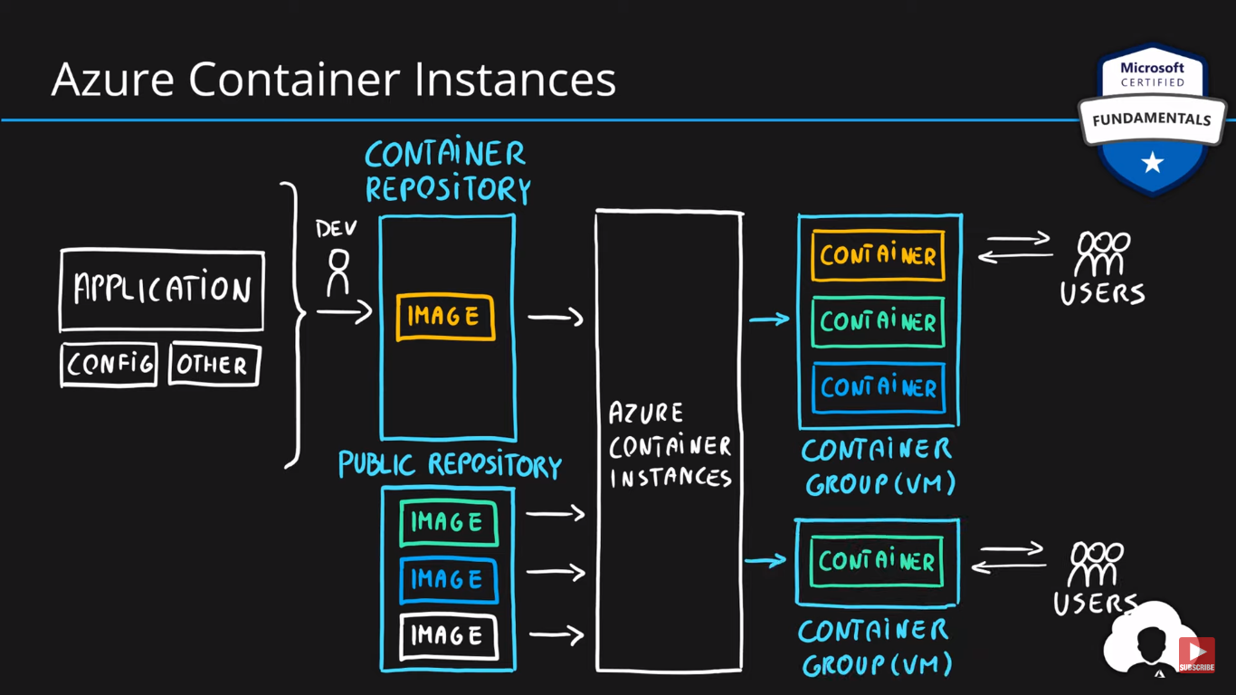

Search for container instances and create one with your requirements and deploy it

After deploying it copy the IP address <http://98.64.172.26/> and open it in new tab

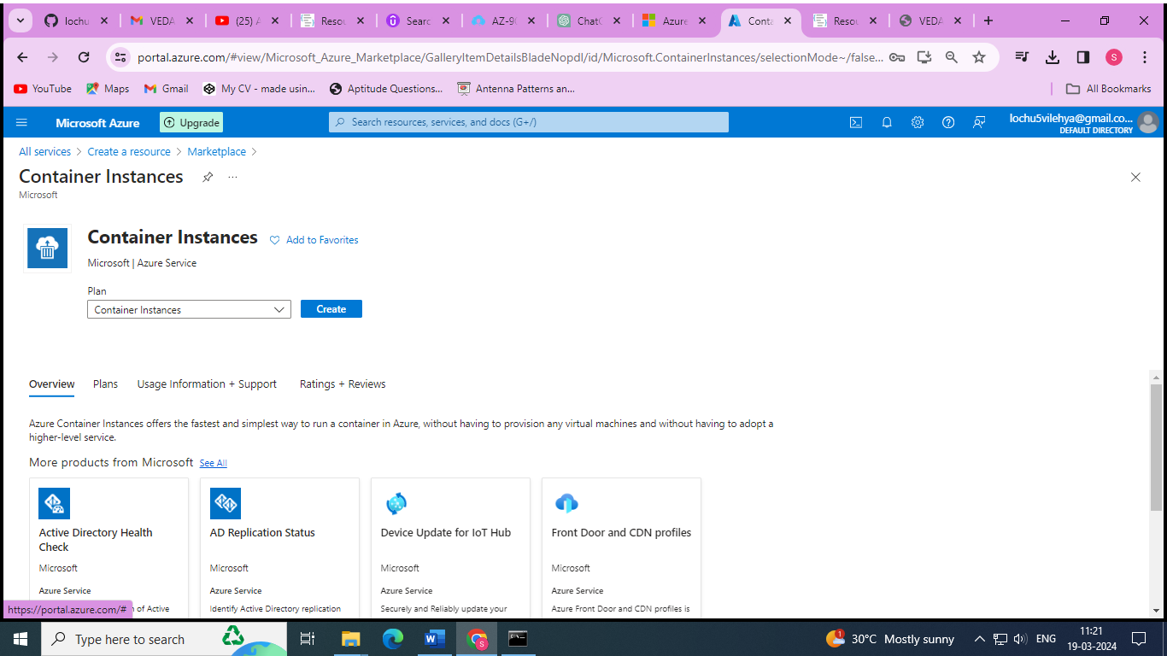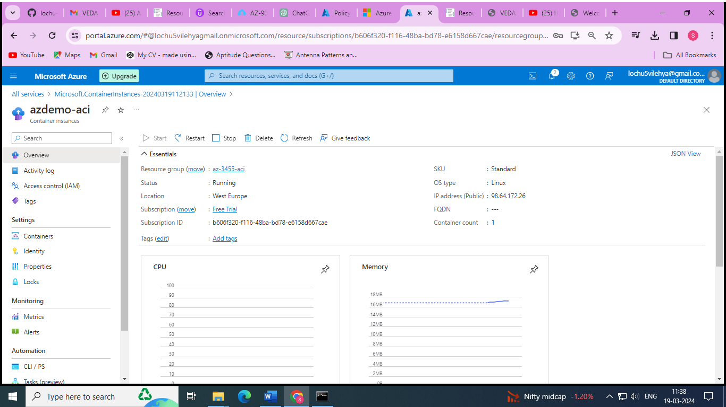

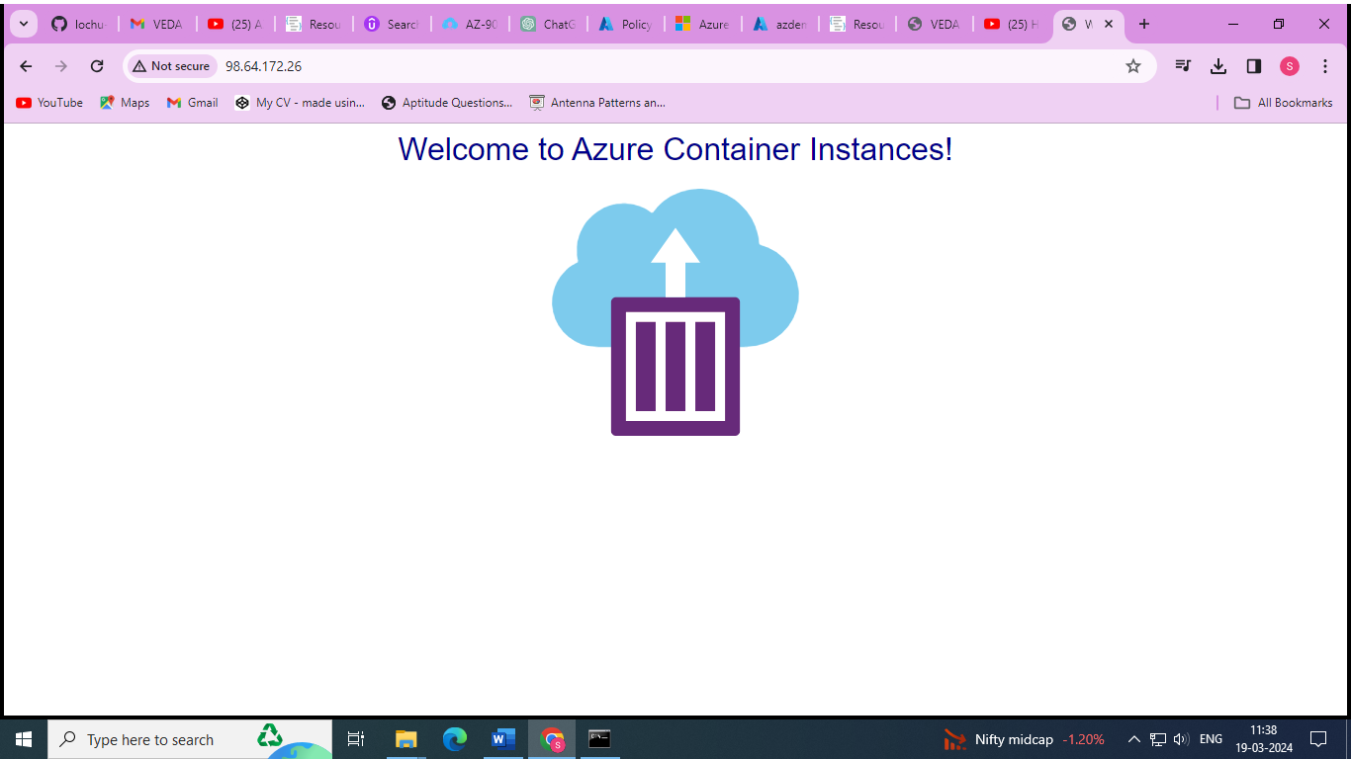

## **Azure Kubernetes Service (AKS)**

* Open-source container orchestration platform
* Platform as a Service
* Highly scalable and customizable
* Designed for high scale container deployments (anything really!)

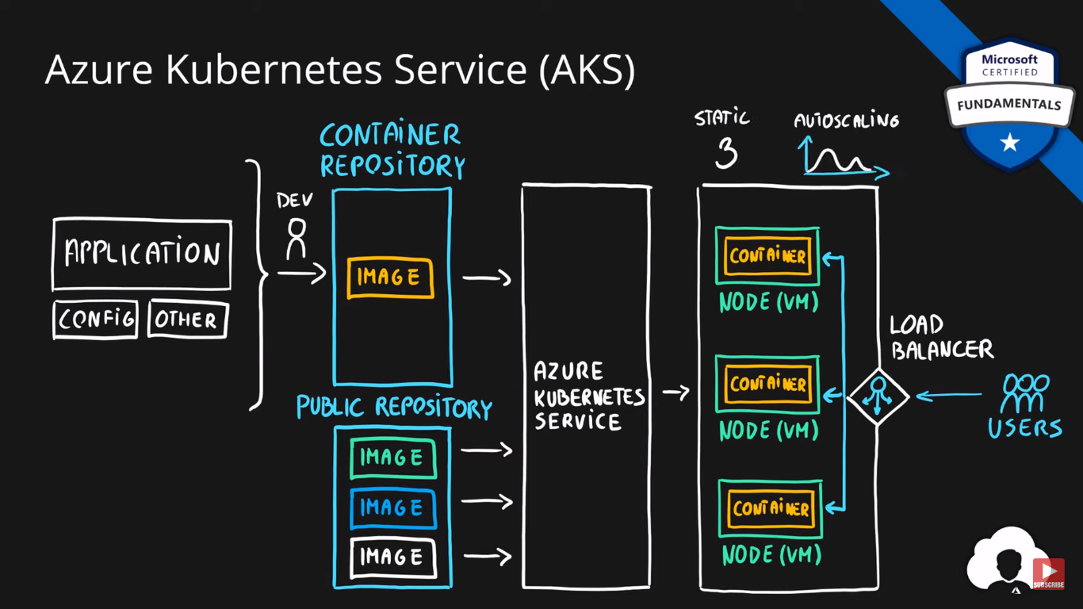

## **App Service**

* Designed as enterprise grade web application service
* Platform as a Service
* Supports multiple programming languages and containers

Go to Web_app 🡪 create a new web app with new resource group 🡪 deploy it

After that copy the Default domain

[azdemo-app.azurewebsites.net](https://azdemo-app.azurewebsites.net/)

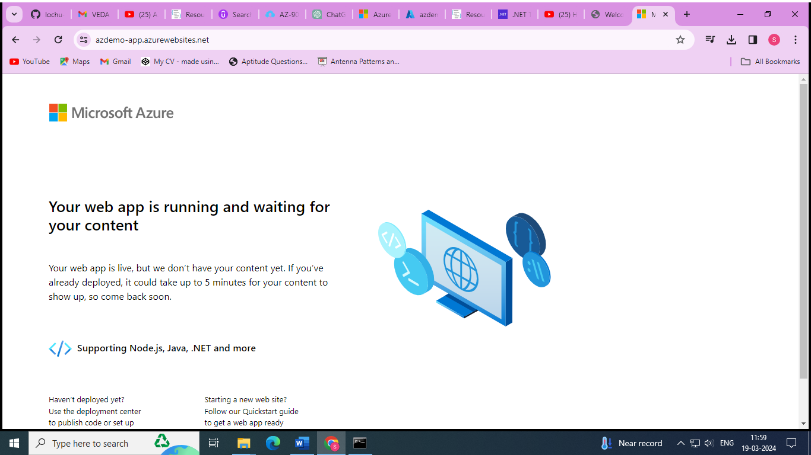

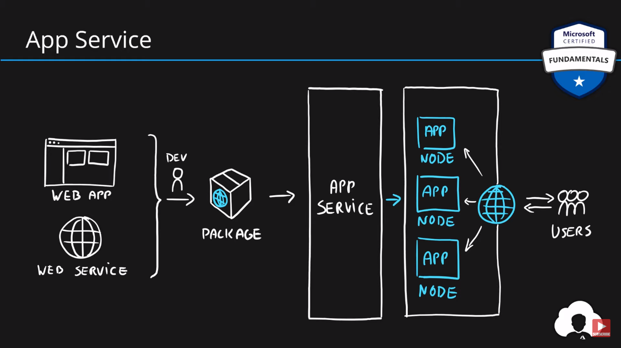

## **Azure Functions (Function Apps)**

* Platform as a Service
* Serverless
* Two hosting/pricing models
  + Consumption-based plan
  + Dedicated plan
* Designed for micro/nano-services

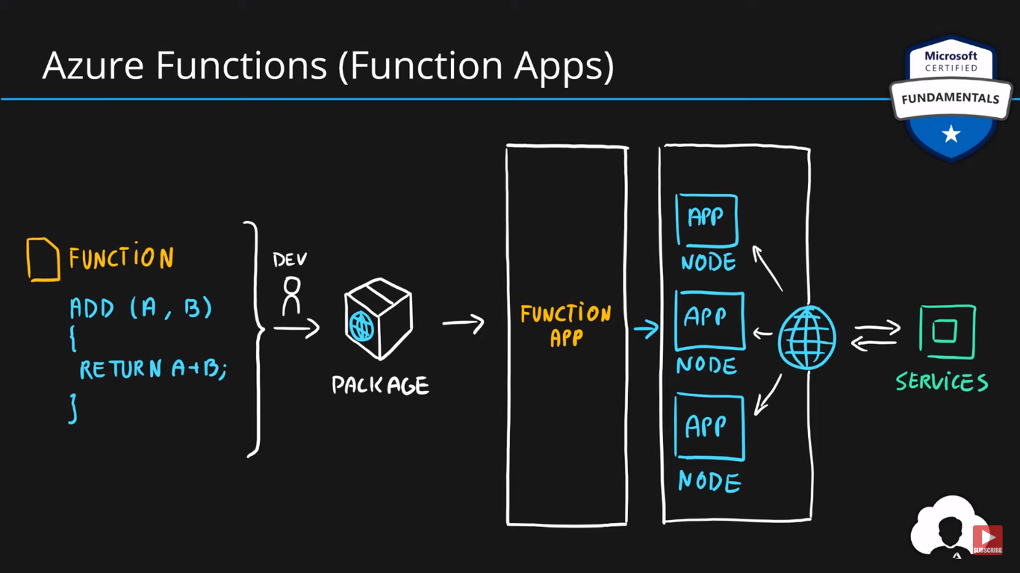

# **Summary**

* Virtual Machines (IaaS) - Custom software, custom requirements, very specialized, high degree of control
* VM Scale Sets (IaaS) - Auto-scaled workloads for VMs
* Container Instances (PaaS) - Simple container hosting, easy to start
* Kubernetes Service (PaaS) - Highly scalable and customizable * container hosting platform
* App Services (PaaS) - Web applications, a lot of enterprise web * hosting features, easy to start
* Functions (PaaS) (Function as a Service) (Serverless) - micro/nano-services, excellent consumption-based pricing, easy to start

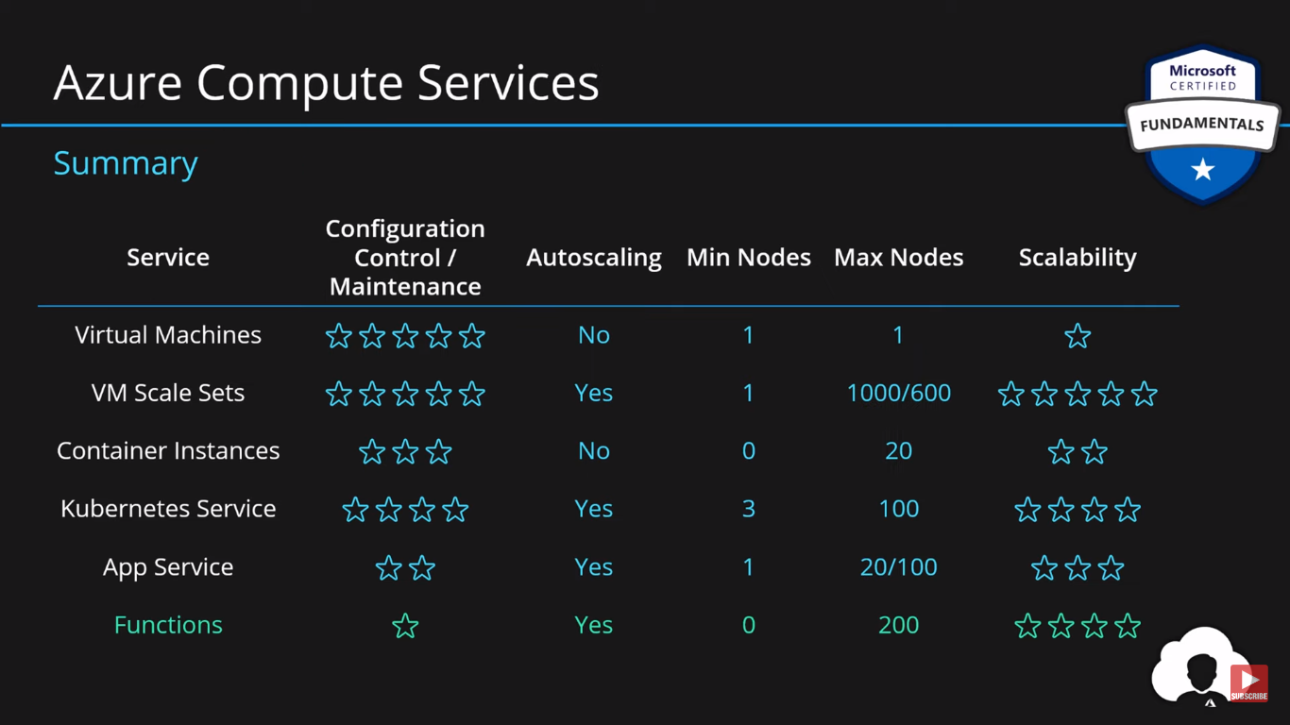

# Networking Services

## **Azure Networking**

* Connect cloud and on-premises
* On-premise networking functionality

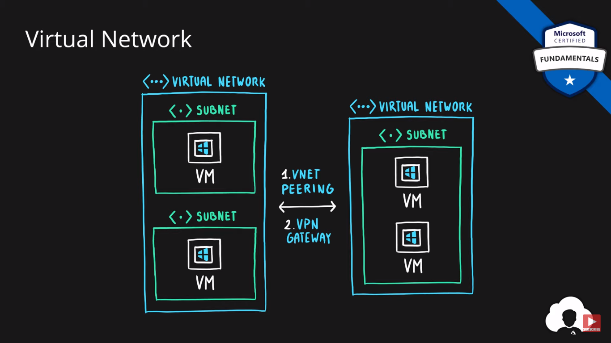

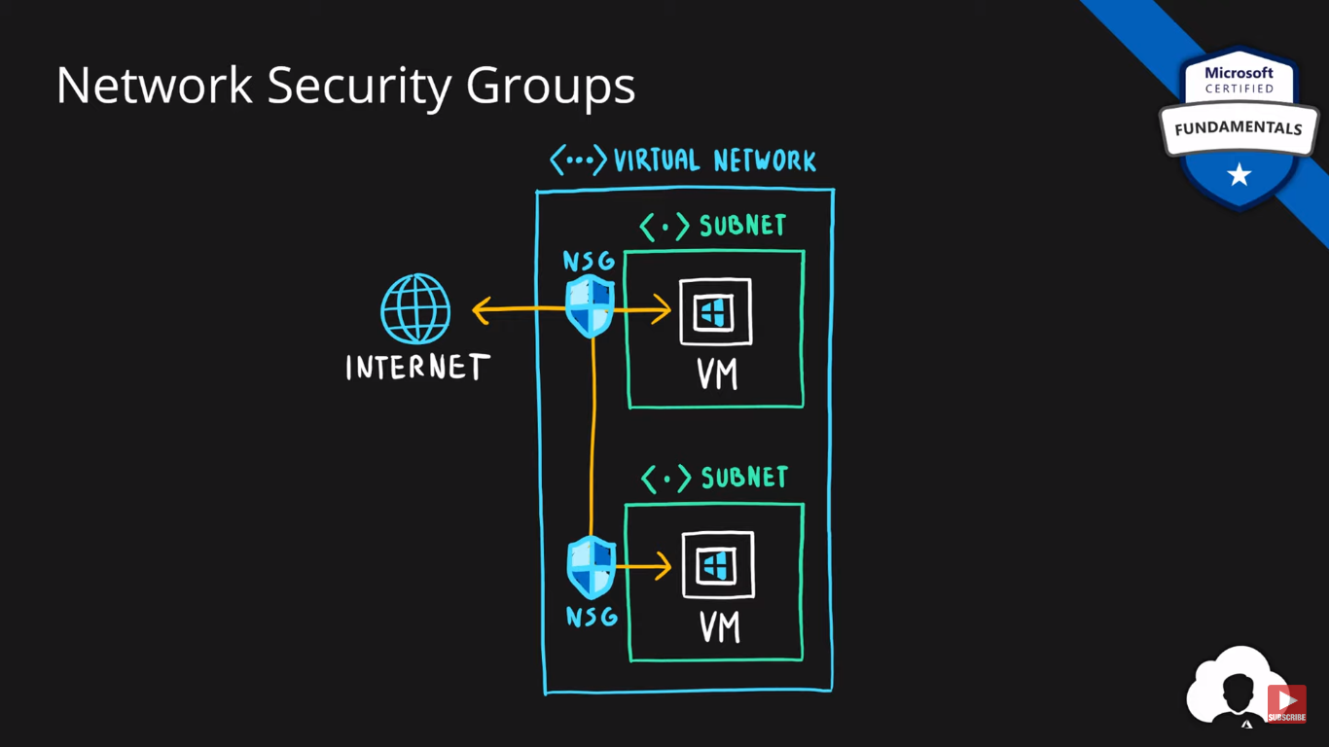

### Azure Virtual Network

* Logically isolated networking components
* Segmented into one or more subnets
* Subnets are discrete sections
* Enable communication of resources with each-other, internet and on-premises
* Scoped to a single region
* VNet peering allow cross region communication
* Isolation, Segmentation, Communication, Filtering, Routing

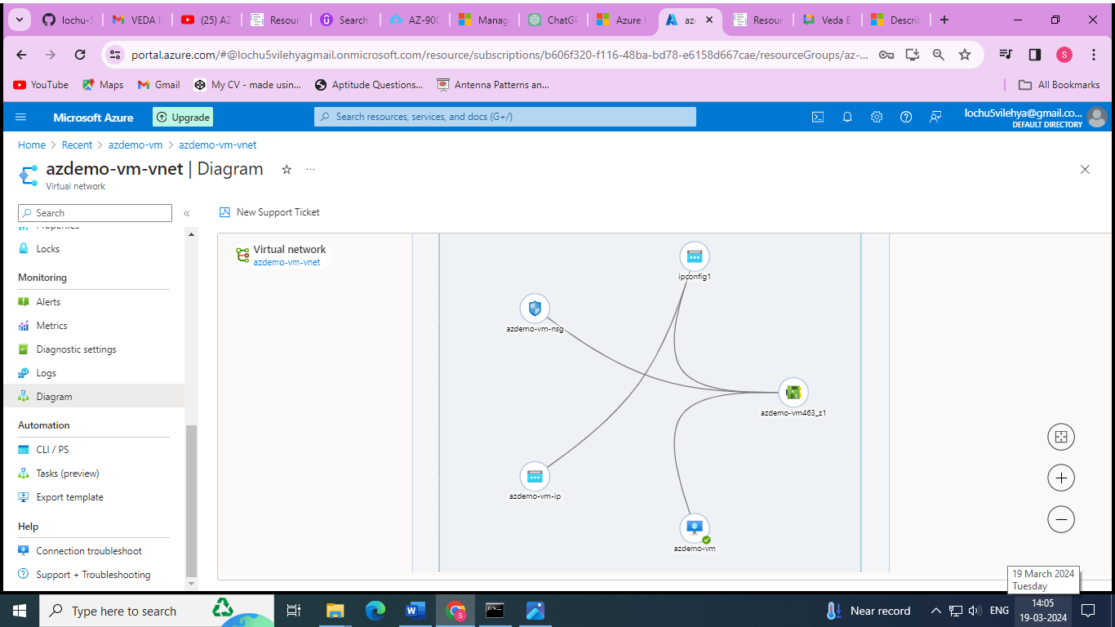

### Azure Load Balancer

* Even traffic distribution
* Supports both inbound and outbound scenarios
* High-availability scenarios
* Both TCP (transmission control protocol) and UDP (user datagram protocol) applications
* Internal and External traffic
* Port Forwarding
* High scale with up to millions of flows

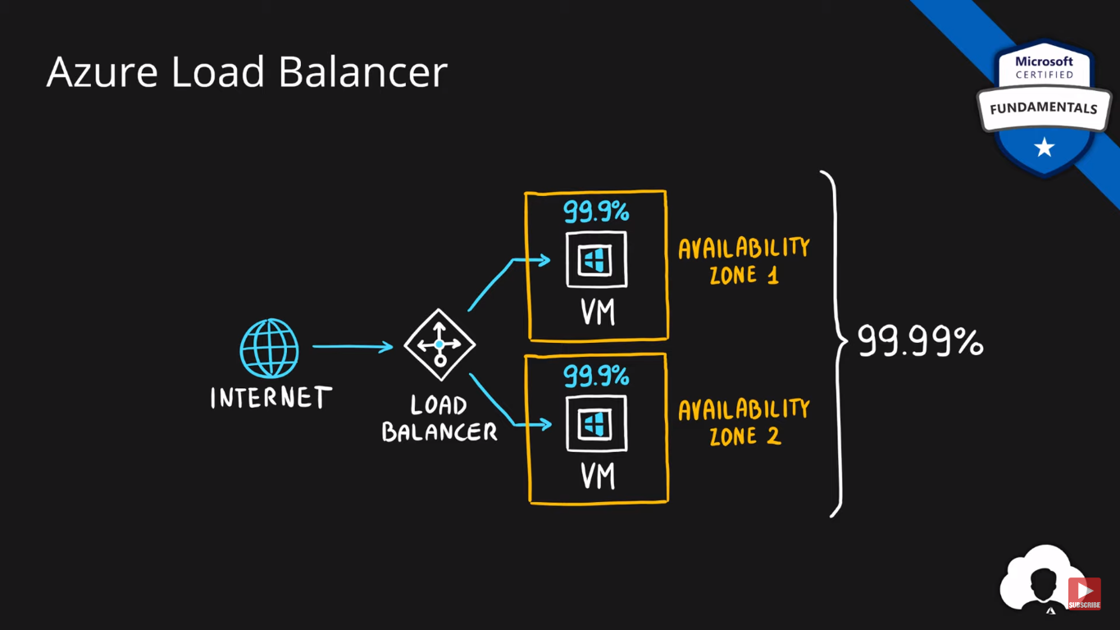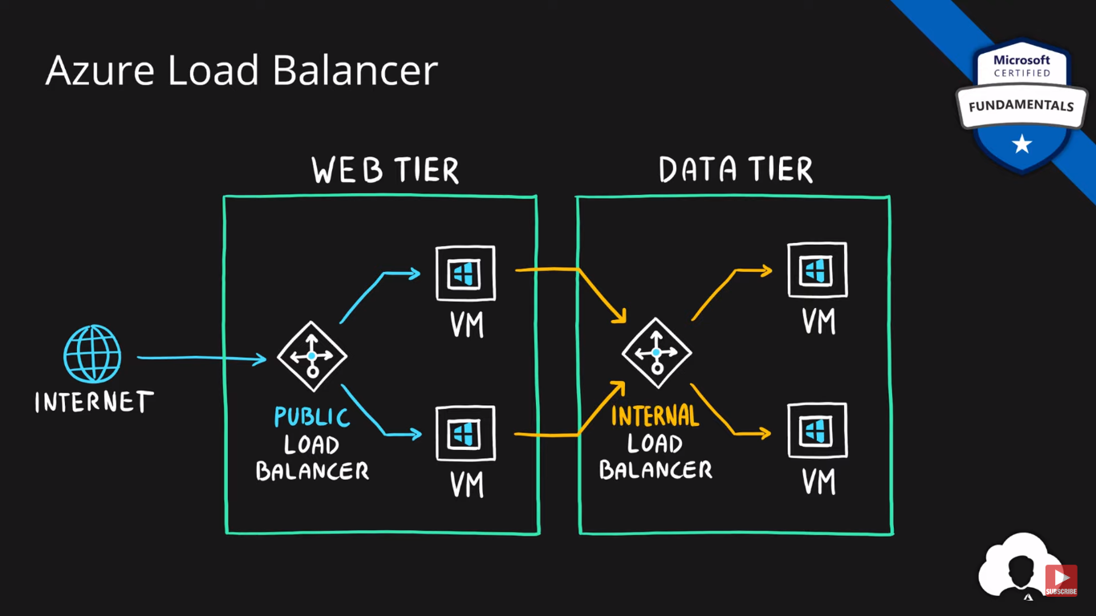

### VPN Gateway

* Specific type of virtual network gateway for on-premises to azure traffic over the public internet

### 

### Application Gateway

* Web traffic load balancer
* Web application firewall
* Redirection
* Session affinity
* URL Routing
* SSL termination

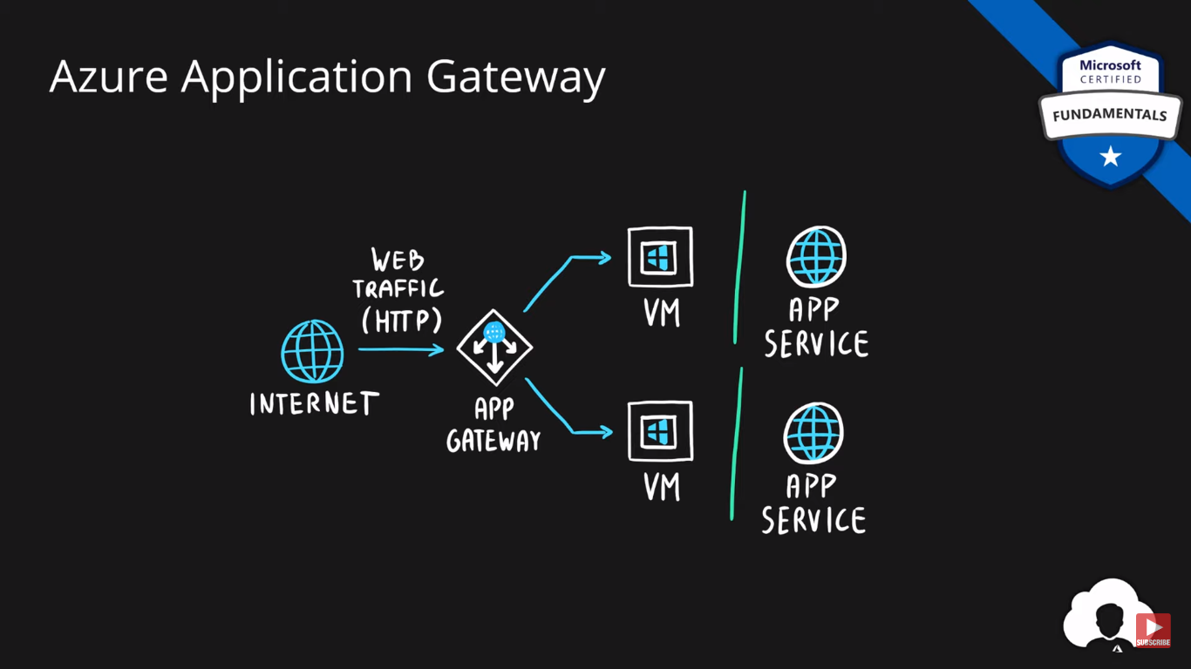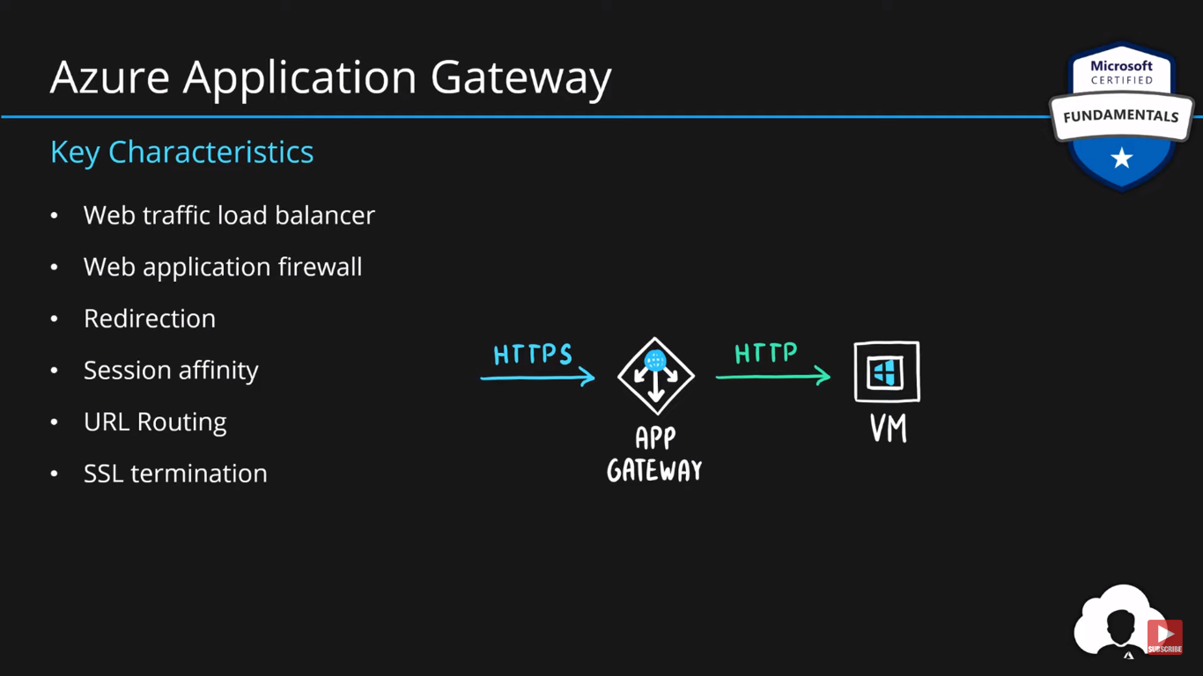

### Content Delivery Network

* Define content
* Minimize latency
* POP (points of presence) with many locations

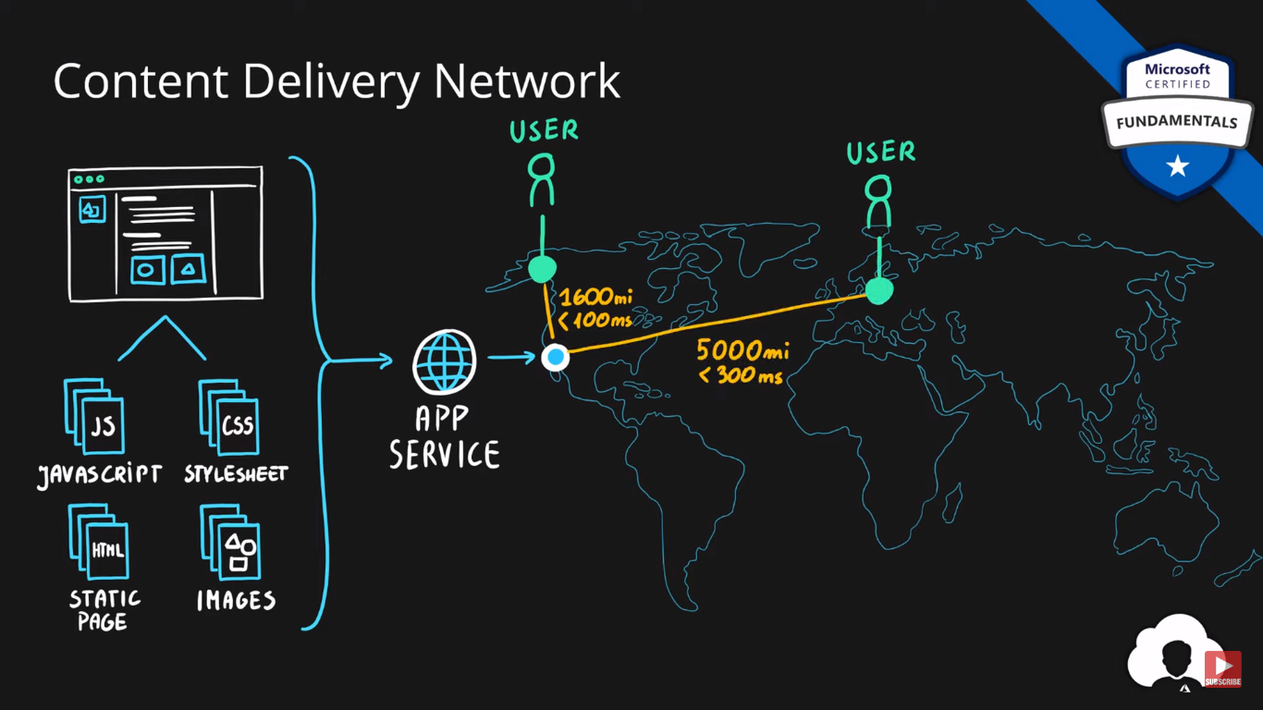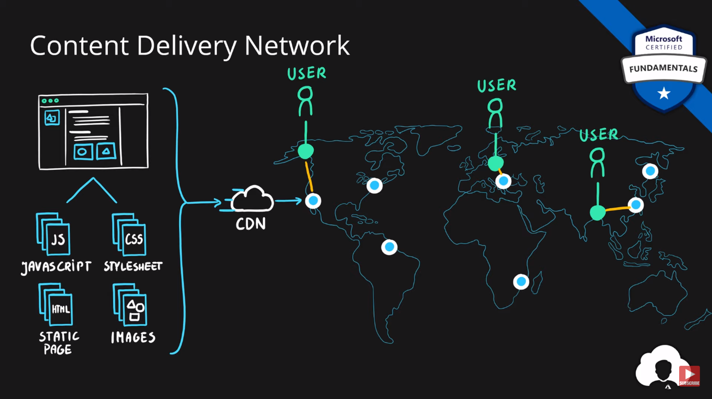

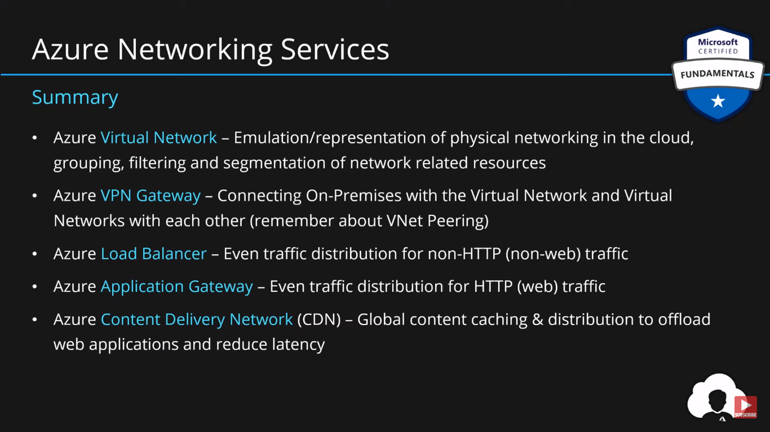

# Azure Storage Services

## **Data Types**

* Structured - Data that can be represented using tables with very strict schema. Each row must follow defined schema. Some tables have defined relationships between them. Typically used in relational databases.
* Semi-structured - Data that can be represented using tables but without strict defined schema. Rows must only have unique key identifier.
* Unstructured - Any files in any format. Like binary files, application files, images, movies, etc.

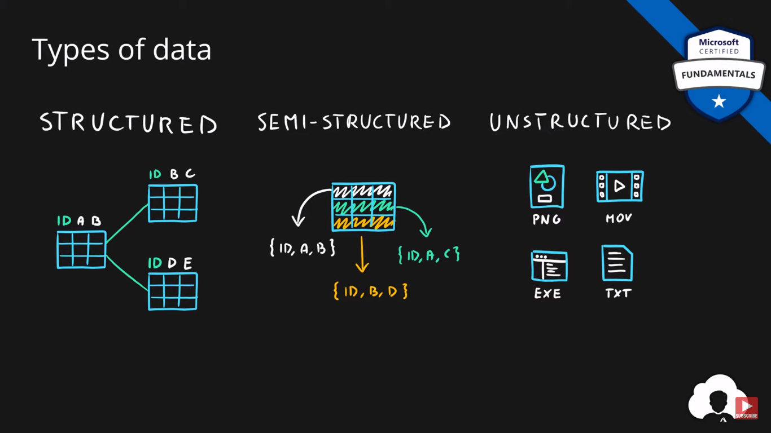

## **Storage Account**

* Group of services which include
  + blob storage,
  + queue storage,
  + table storage, and
  + file storage
* Used to store
  + files,
  + messages, and
  + semi-structured data
* Highly scalable (up to petabytes of data)
* Highly durable (99.999999999% - 11 nines, up to 16 nines)
* Cheapest per GB storage

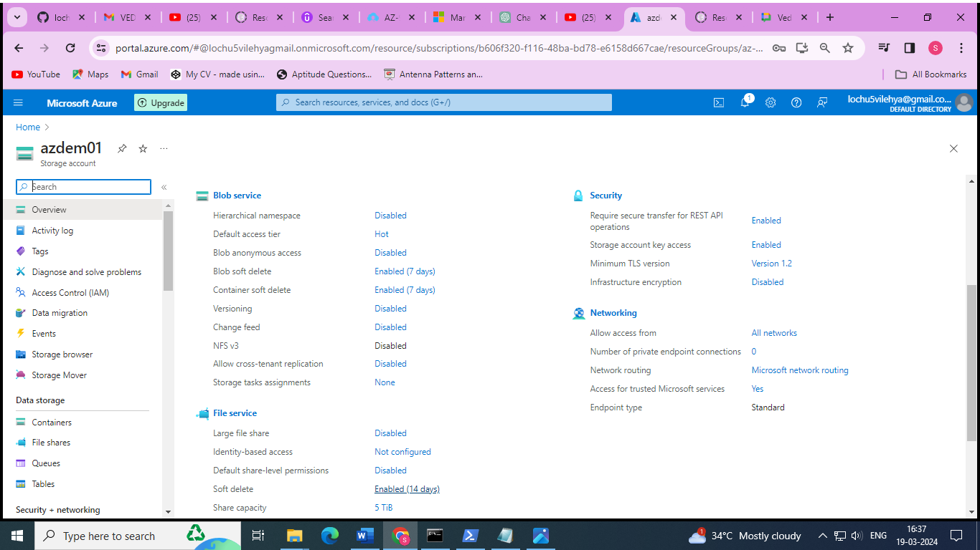

## **Blob Storage**

* BLOB – binary large object – file
* Designed for storage of files of any kind
* Three storage tiers
  + Hot – frequently accessed data
  + Cool – infrequently accessed data (lower availability, high durability)
  + Archive – rarely (if-ever) accessed data

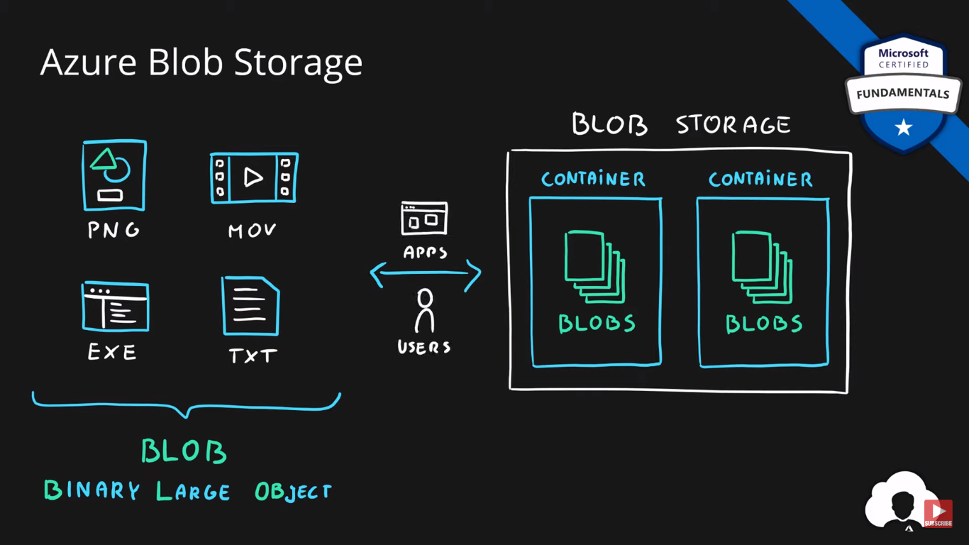

## 

## **Queue Storage**

* Storage for small pieces of data (messages)
* Designed for scalable asynchronous processing

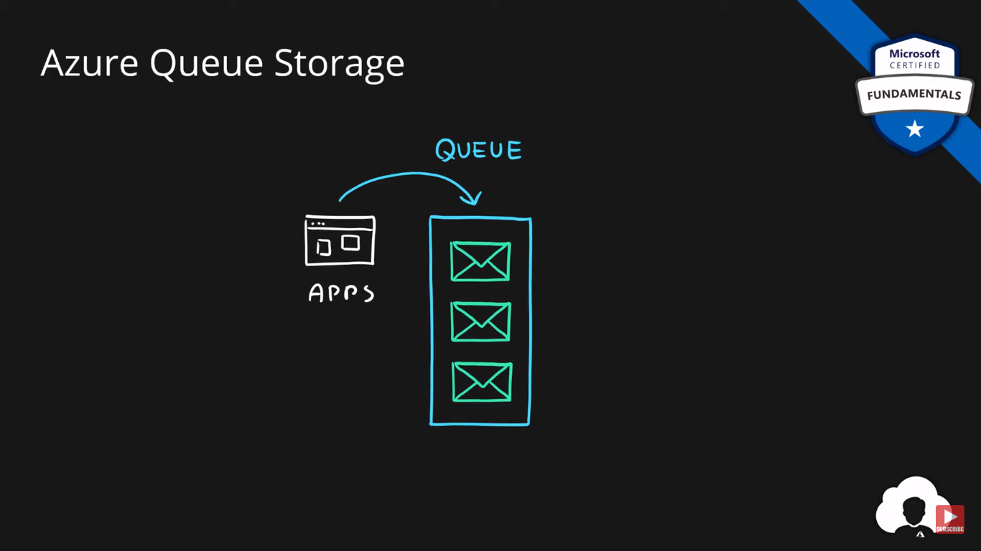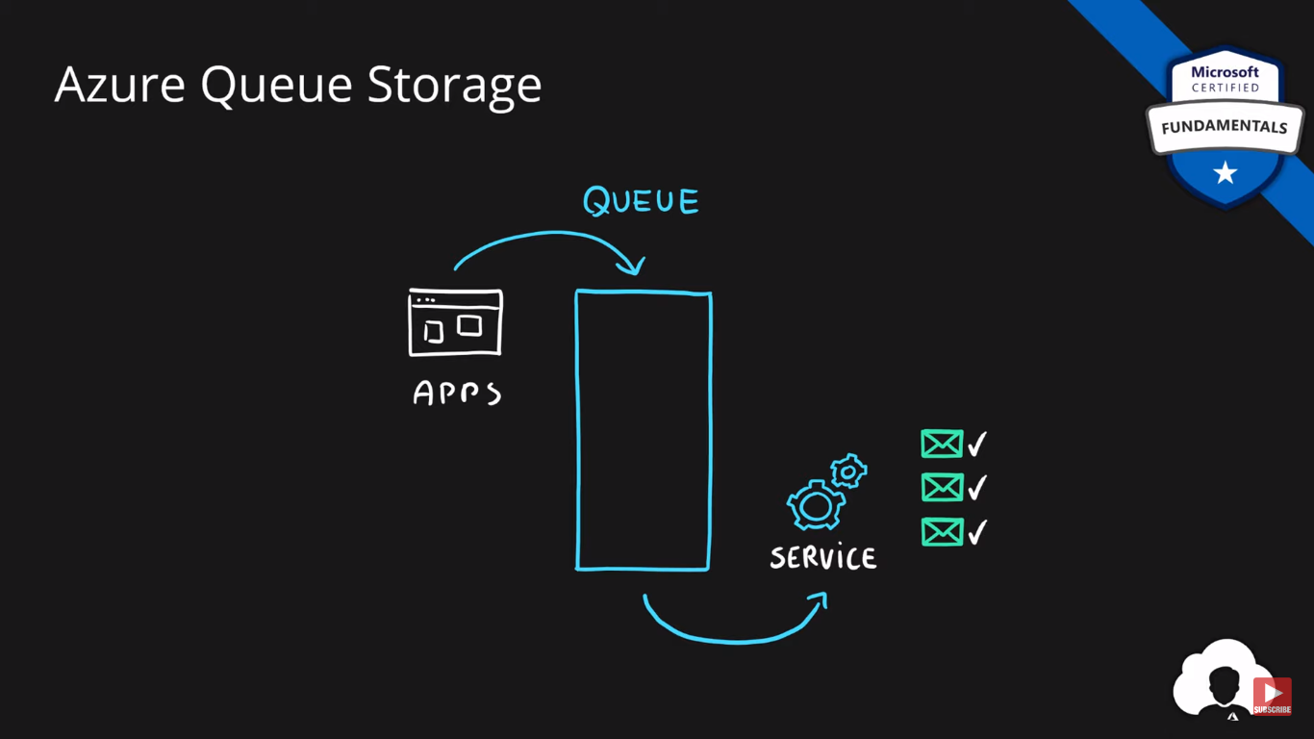

## **Table Storage**

* Storage for semi-structured data (NoSQL)
  + No need for foreign joins, foreign keys, relationships or strict schema
  + Designed for fast access
* Many programming interfaces and SDKs

## 

## Goto to Storage browser 🡪 go to tables 🡪 create one table 🡪 add entity with separate keys and property 🡪 press enter

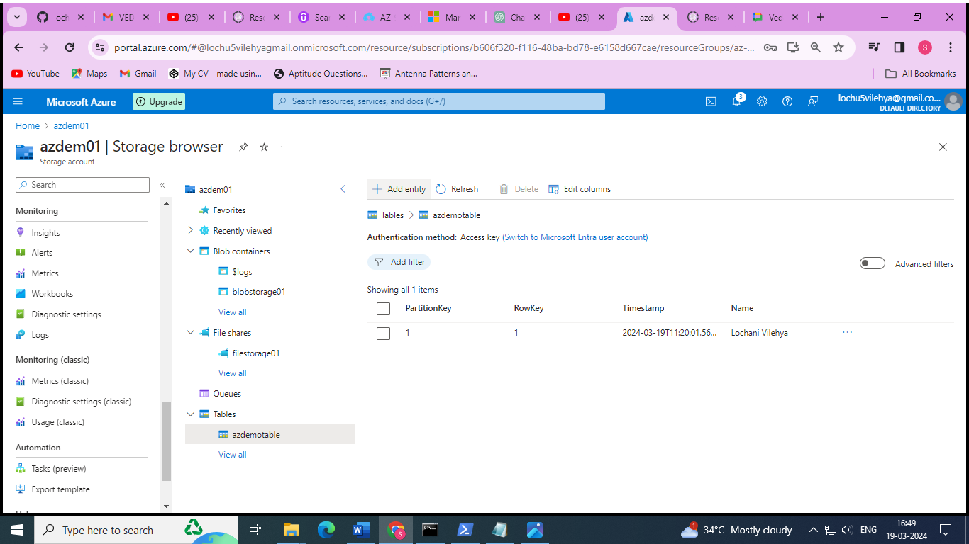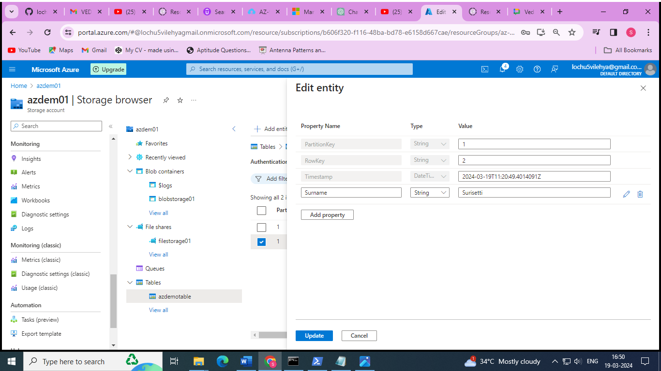

## **File Storage**

* Storage for files accessed via shared drive protocols
* Designed to extend on-premise file shares or implement lift-and-shift scenarios

Create a file storage service in storage accounts 🡪 go to connect option 🡪 copy the script and run it in windows power shell 🡪 then same file share folder will be created in your local machine 🡪create anew text file in it 🡪 refresh the file share ion azure to get those files added in the local file share folder

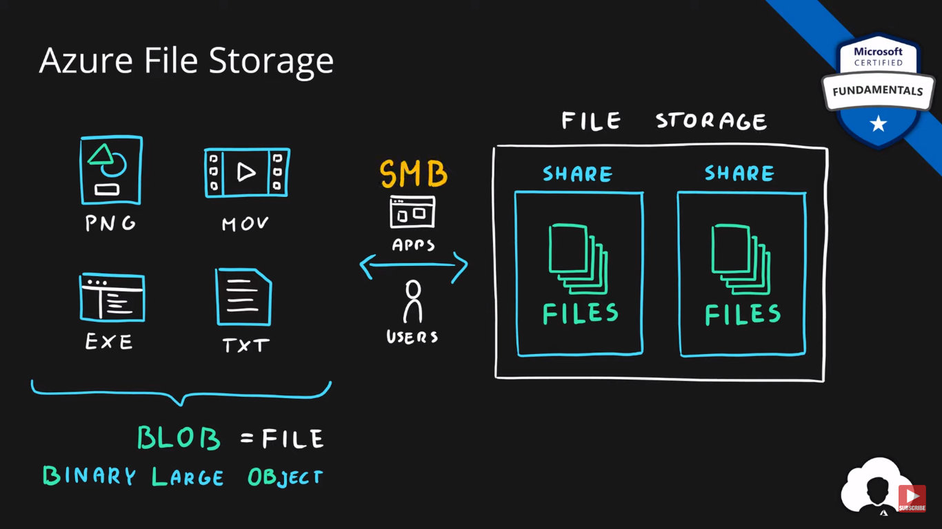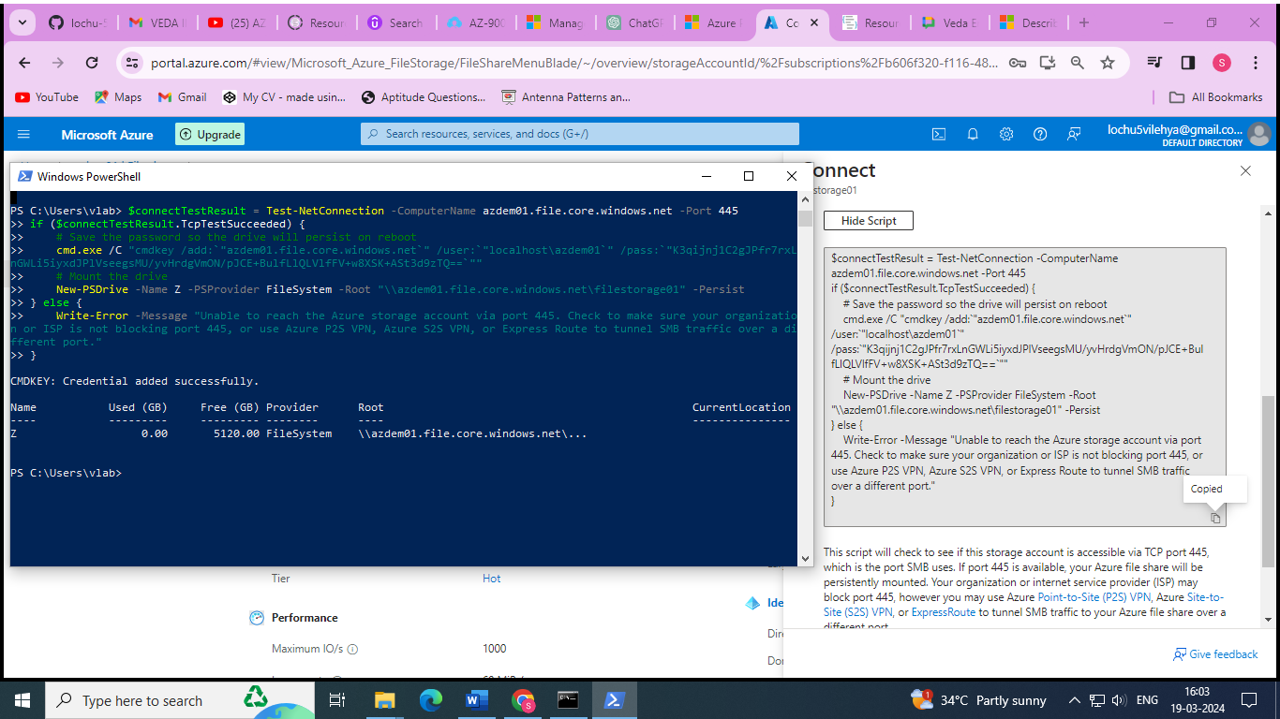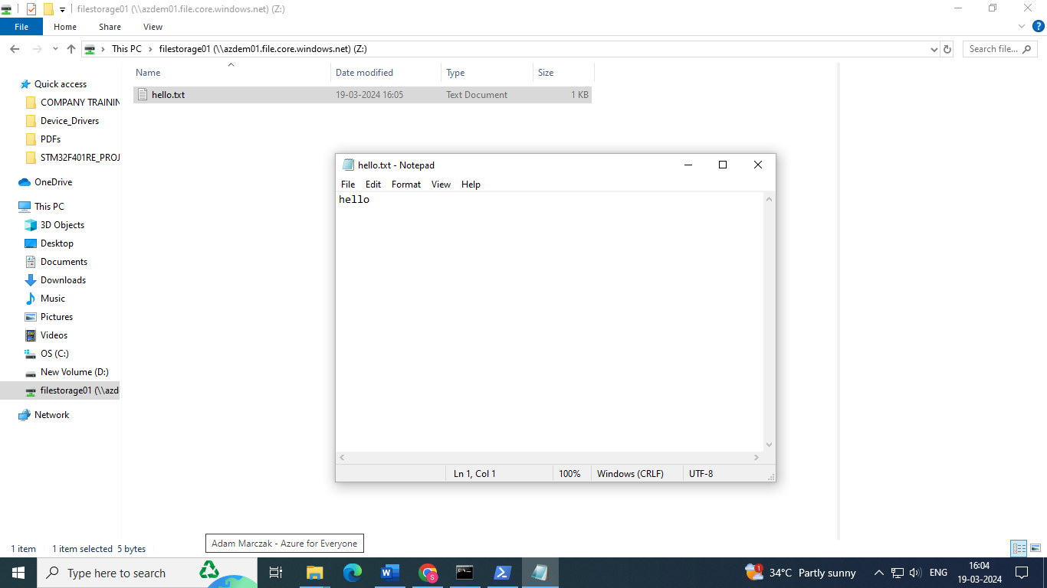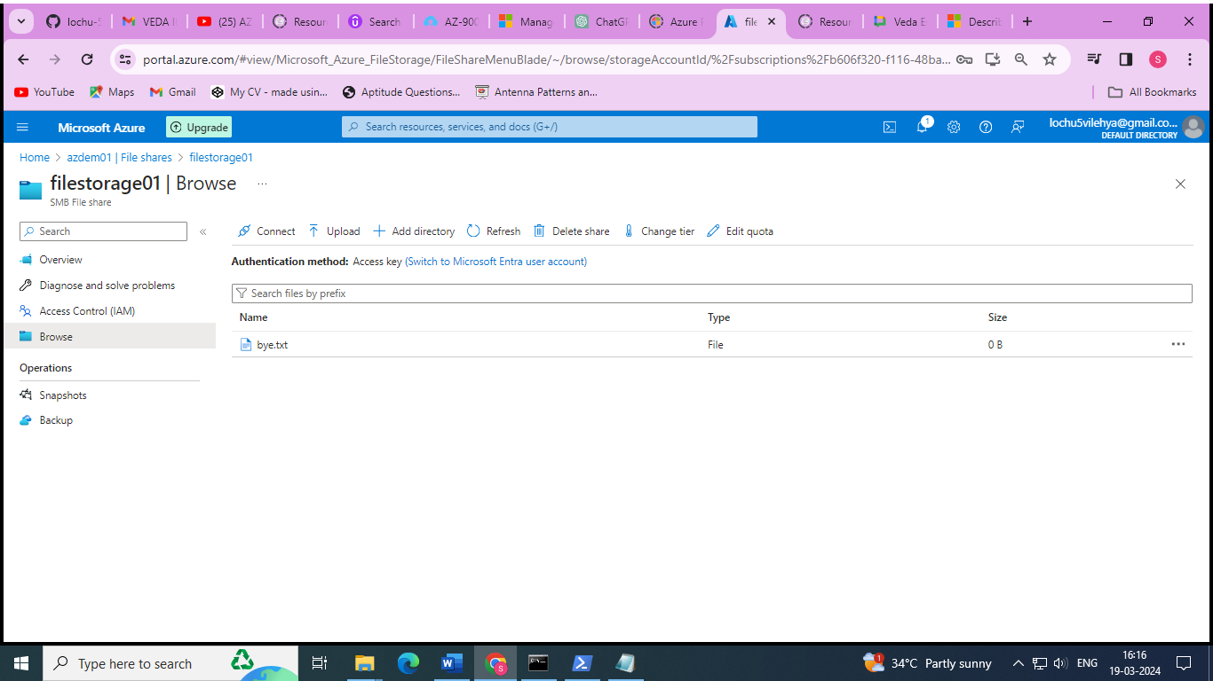

## **Disk Storage**

* Disk emulation in the cloud
* Persistent storage for Virtual Machines
* Different
  + sizes,
  + types (SSD, HDD)
  + performance tiers
* Disk can be unmanaged or managed

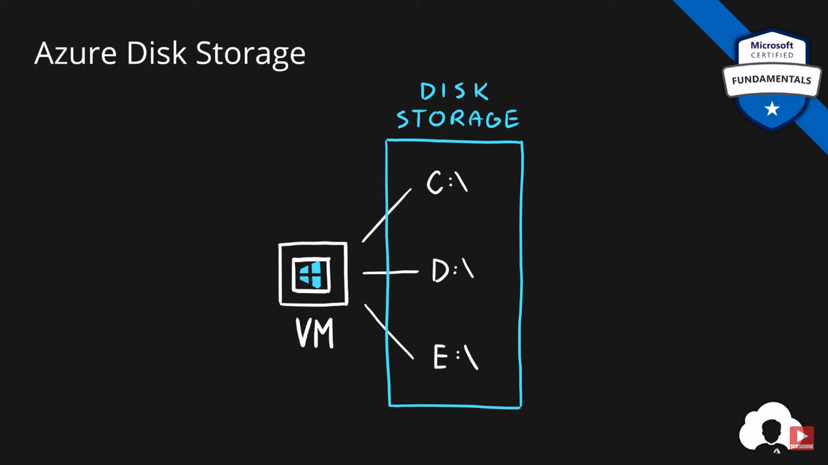

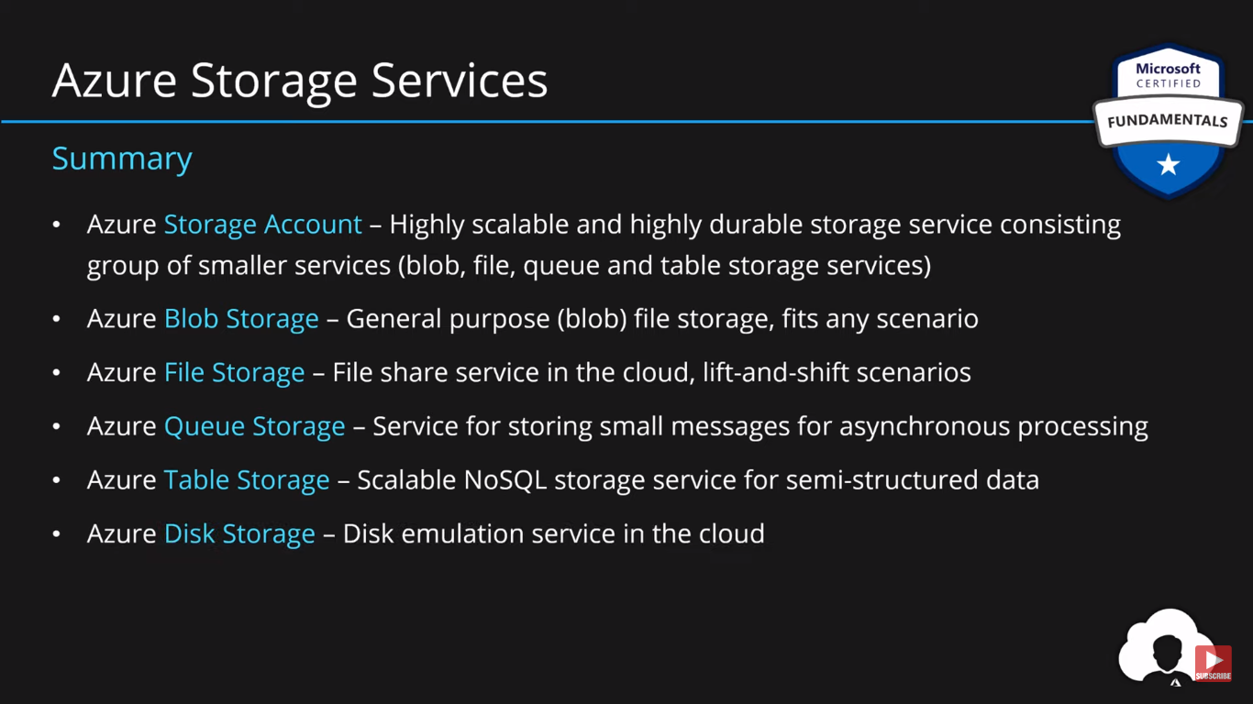

# Database Services

## **Data Types**

* **Structured** - Data that can be represented using tables with very strict schema. Each row must follow defined schema. Some tables have defined relationships between them. Typically used in relational databases.
* **Semi-structured** - Data that can be represented using tables but without strict defined schema. Rows must only have unique key identifier.
* **Unstructured** - Any files in any format. Like binary files, application files, images, movies, etc.

## **Cosmos DB**

* Globally distributed NoSQL (semi-structured data) Database service
* Schema-less
* Multiple APIs (SQL, MongoDB, Cassandra, Gremlin, Table Storage)
* Designed for
  + Highly responsive (real time) applications with super low latency responses <10ms
  + Multi-regional applications

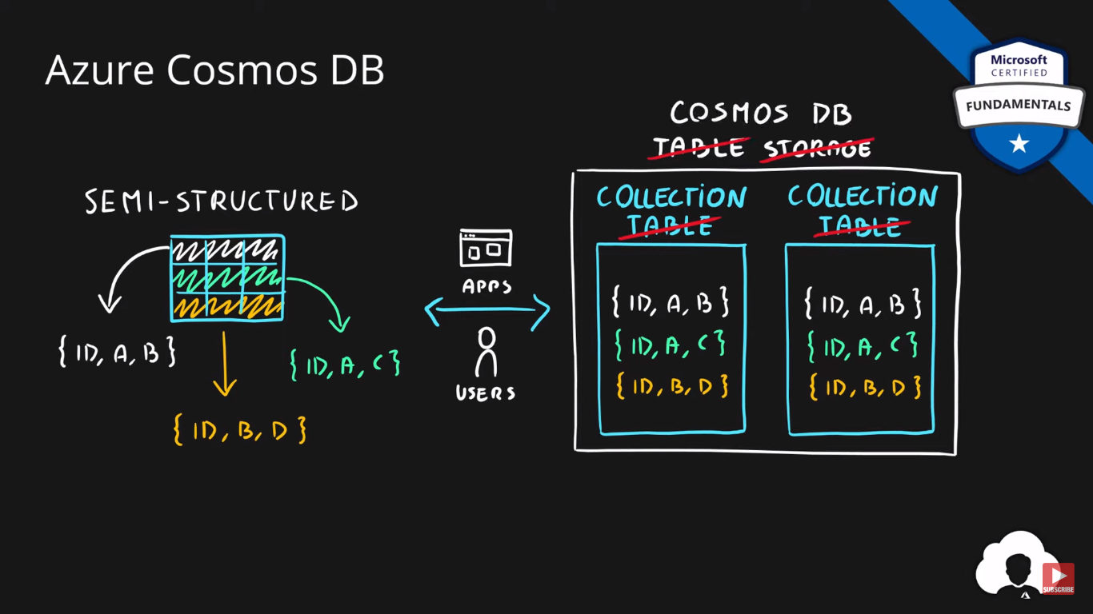

## 

## **SQL Database**

* **Relational database** service in the cloud (PaaS) (DBaaS - Database as a Service)
* **Structured data service** defined using schema and relationships
* **Rich Query Capabilitie**s (SQL)
* **High-performance**, reliable, fully managed and secure database for building – applications

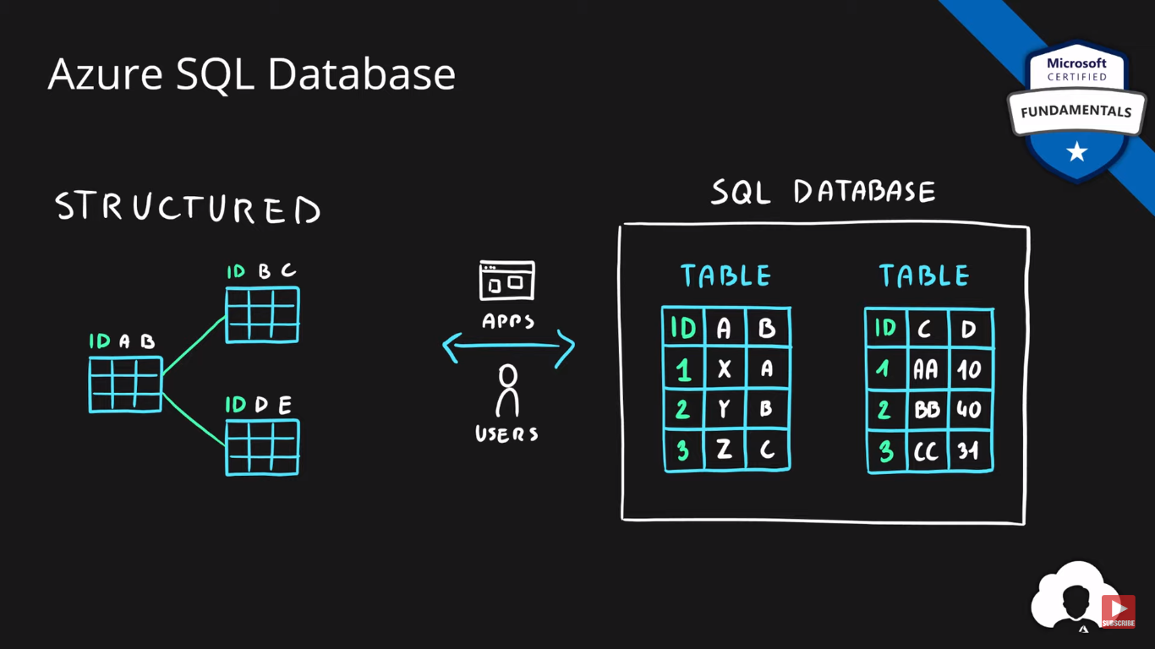

## **Azure SQL product family**

* Azure **SQL Database** – Reliable relational database based on SQL Server
* Azure **Database for MySQL** – Azure SQL version for MySQL database engine
* Azure **Database for PostgreSQL** – Azure SQL version for PostgreSQL database engine
* Azure **SQL Managed Instance** – Fully fledged SQL Server managed by cloud provider
* Azure **SQL on VM** – Fully fledged SQL Server on IaaS
* Azure **SQL DW (Synapse)** – Massively Parallel Processing (MPP) version of SQL Server

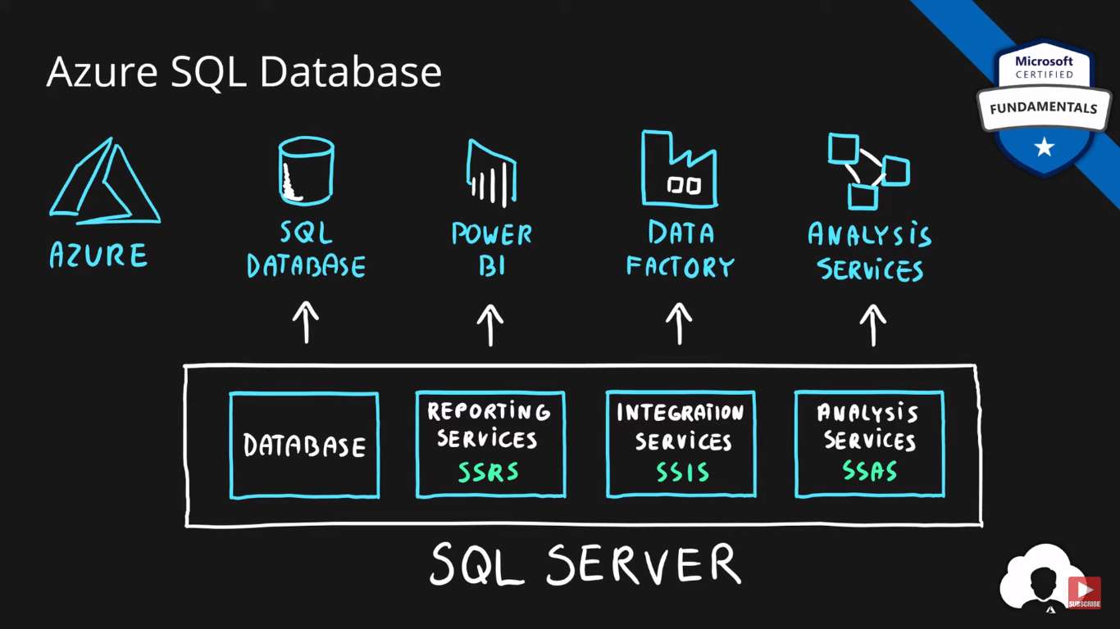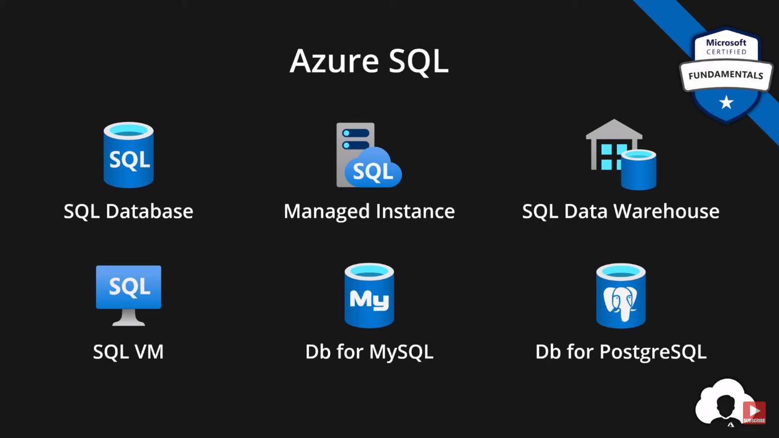

Steps to create a SQL database in the azure :

1. Create a resource 🡪 Search for SQL database 🡪 create a new database
2. Search for private endpoint 🡪 create an endpoint for the created SQL server resource group
3. Go to Networking section on the left column of the created SQL server 🡪 enable the selected networks 🡪 add the firewall rules
4. Go to query editor 🡪 login with server username and password

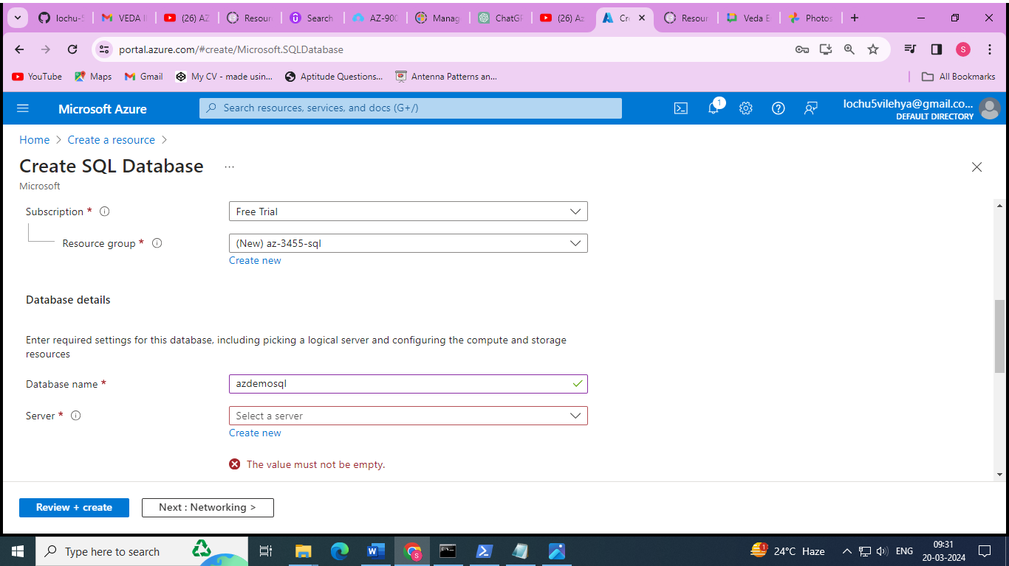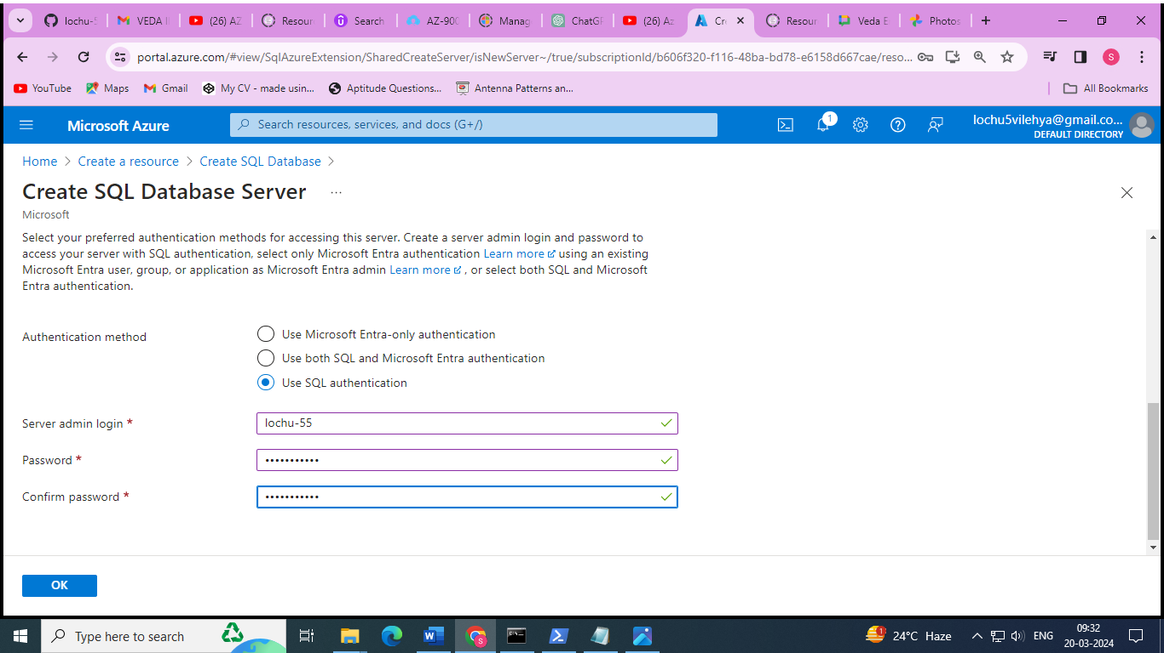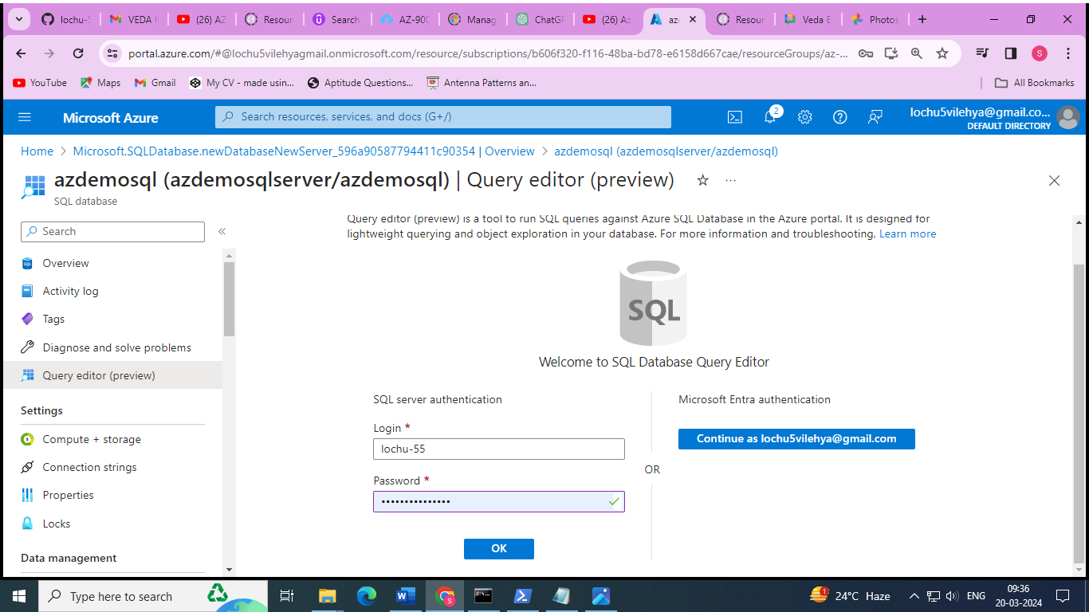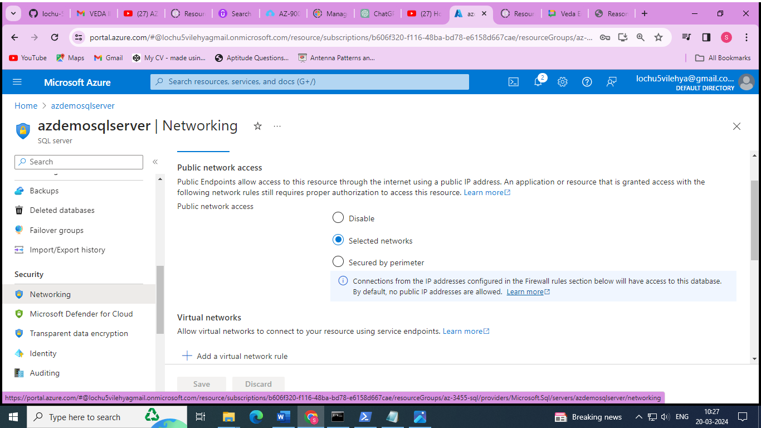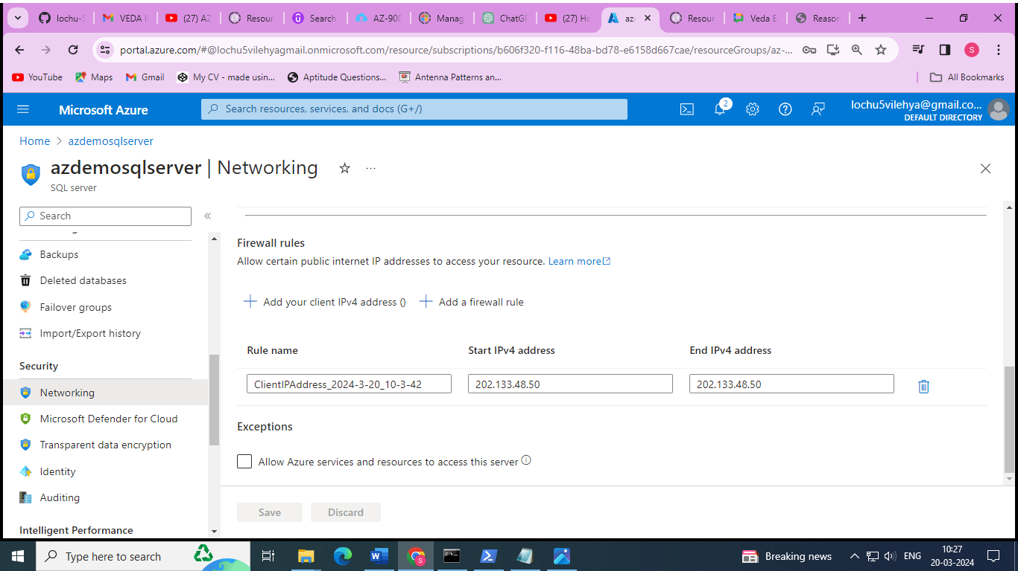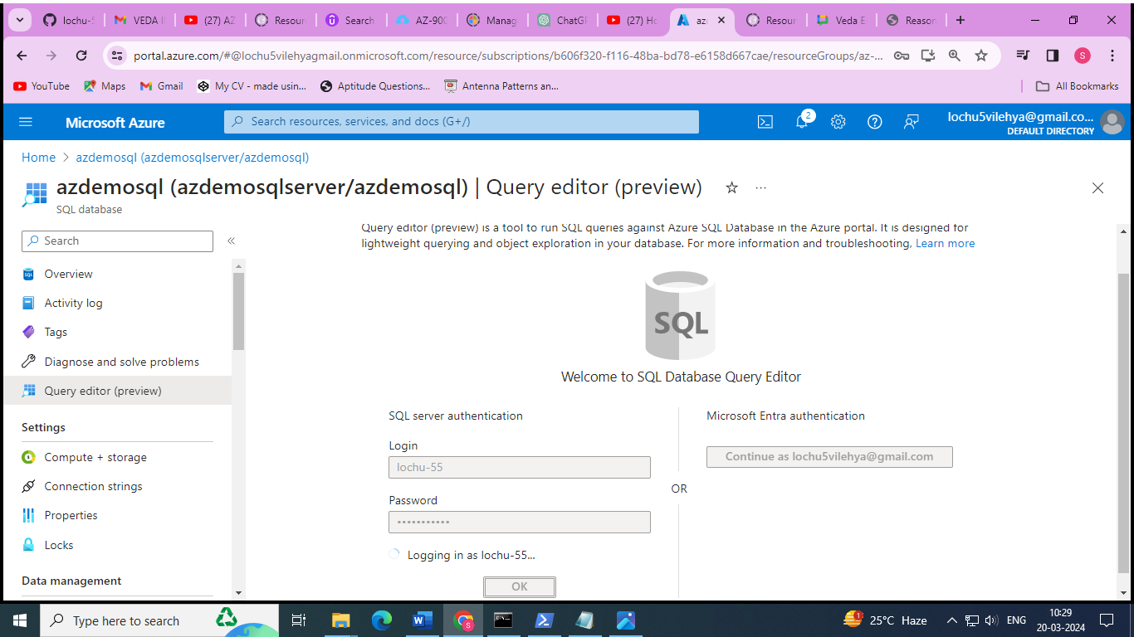

Simple code to create the data base in SQL database server:

CREATE TABLE Movies (

ID int identity (1,1) Primary Key,

Title varchar (100) null,

Genre varchar (100) null

);

-- Insert a single row into the Movies table

INSERT INTO Movies (Title, Genre)

VALUES

('John', 'Sales'),

('Hello','Comedy');

SELECT * FROM [dbo].[Movies]

WHERE Genre LIKE '%ome%'

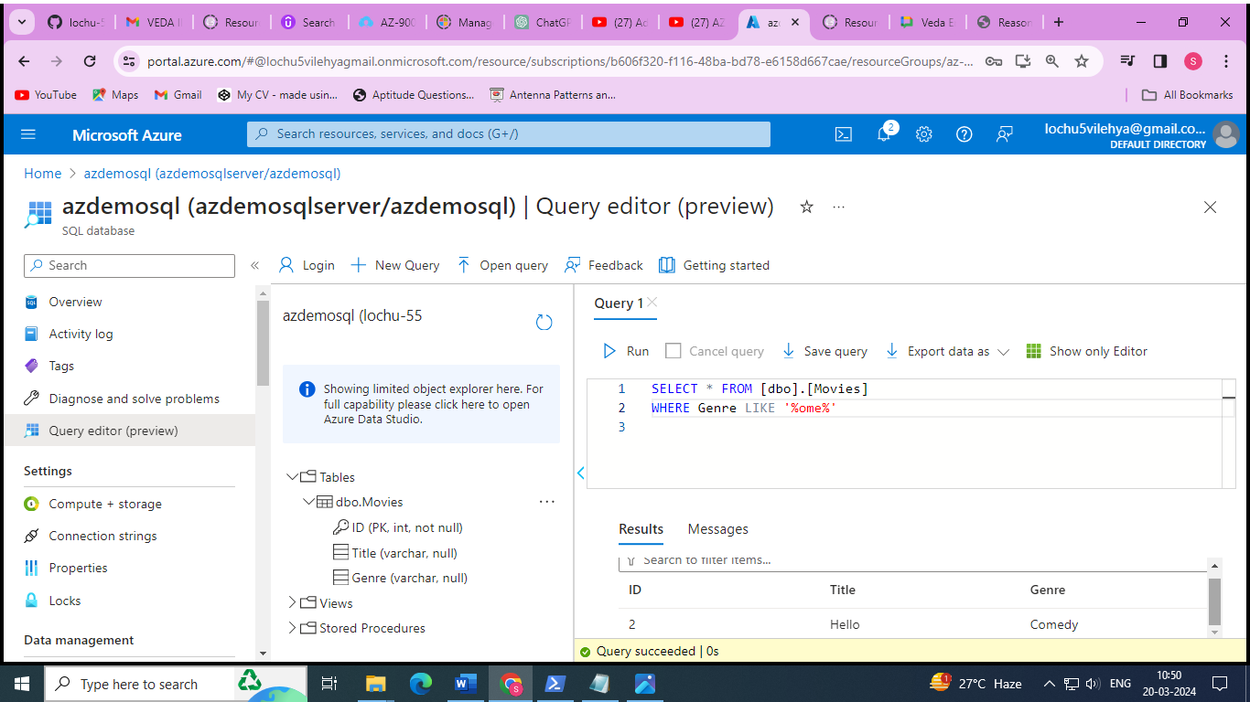

# Azure Marketplace

* Think of it like an “Azure Shop” where you purchase services and solutions for the Azure platform
* Each product is a template which contains one or multiple services
* Products are delivered by first and third-party vendors
* Solutions can leverage all service categories like IaaS, PaaS and SaaS

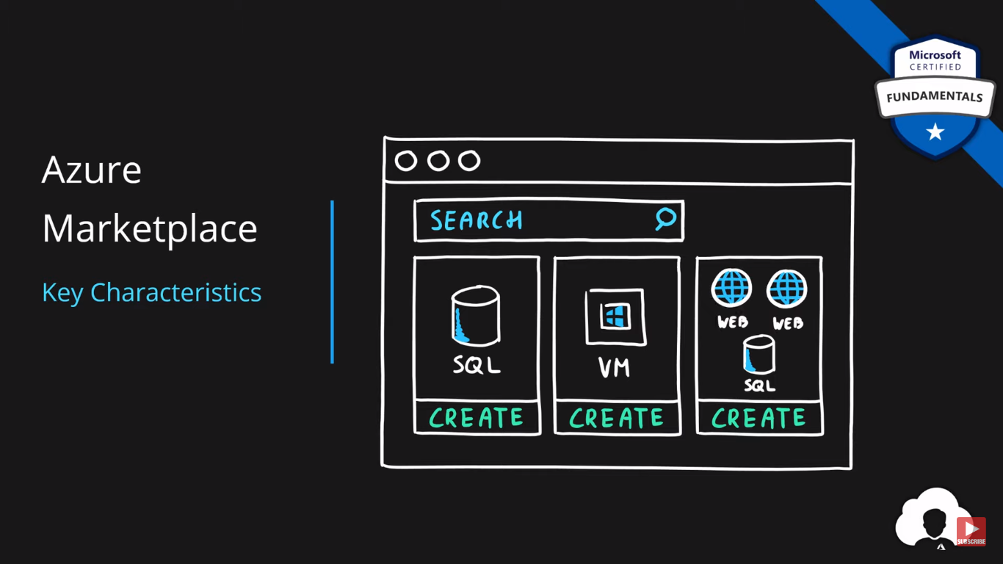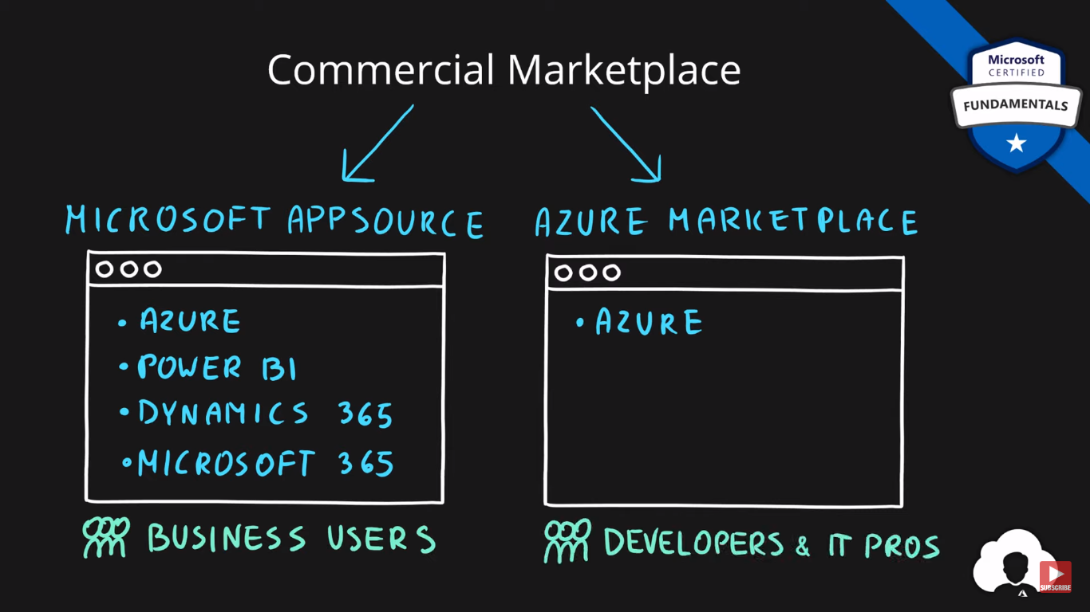

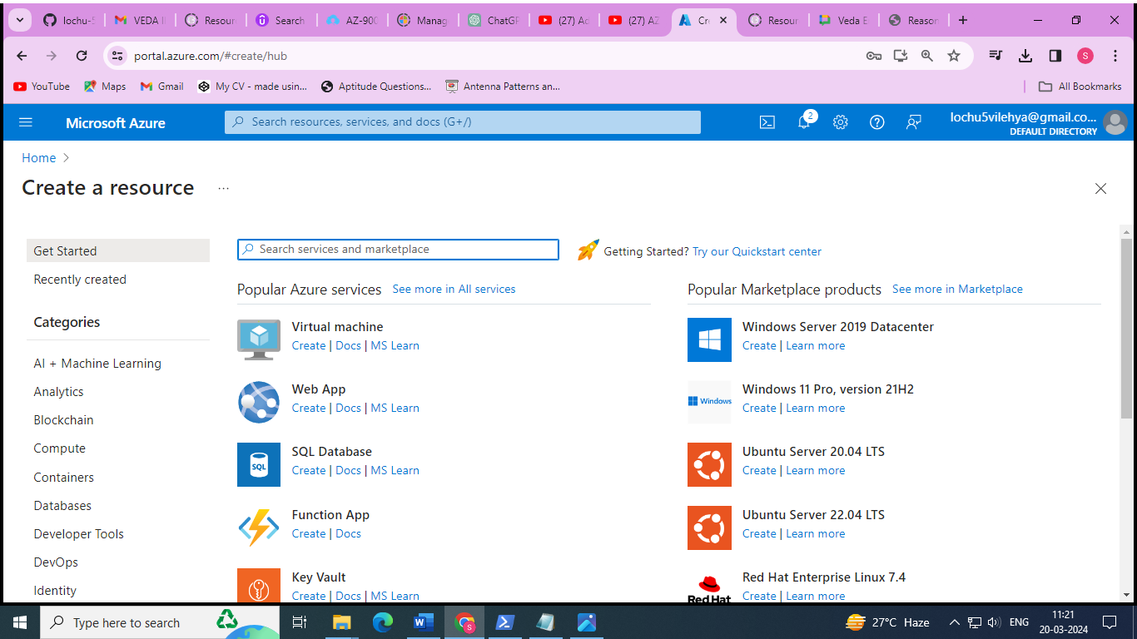

# Azure IoT Services

## **What is Internet of Things?**

Internet of Things (**IoT**) is a network of internet connected devices (**IoT Devices**) embedded in everyday objects enabling sending and receiving data such as **settings** and **telemetry**.

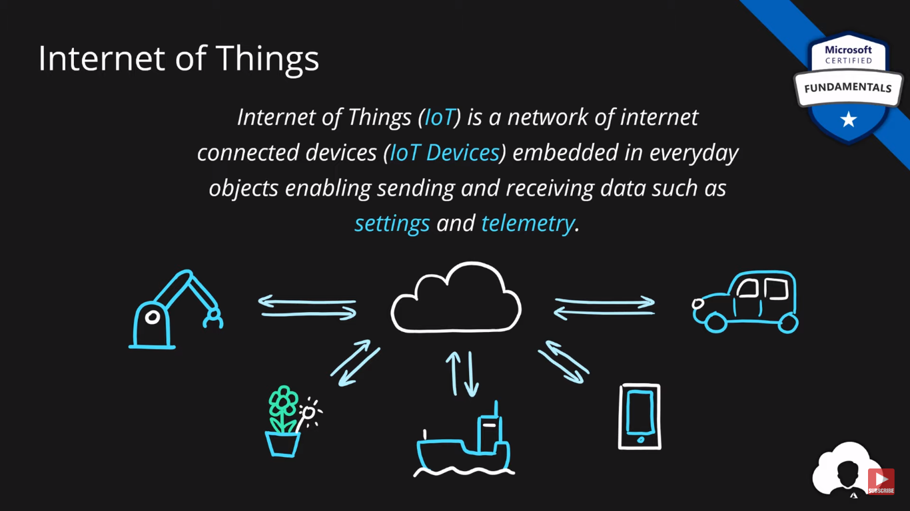

## **Azure Iot Hub**

* Managed service for bi-directional communication
* Platform as a Service (PaaS)
* Highly secure, scalable and reliable
* Integrates with a lot of Azure Services
* Programmable SDKs for popular languages (C, C#, Java, Python, Node.js)
* Multiple protocols (HTTPS, AMQP, MQTT)

## 

## **Azure IoT Central**

* IoT App Platform - Software as a Service (SaaS)
* Industry specific app templates
* No deep technical knowledge required
* Service for connecting, management and monitoring IoT devices
* Highly secure, scalable and reliable
* Built on top of the IoT Hub service and 30+ other services

## 

## **Azure Sphere**

* Secure end-2-end IoT Solutions
  + Azure Sphere certified chips (microcontroller units - MCUs)
  + Azure Sphere OS based on Linux
  + Azure Security Service trusted device-to-cloud communication

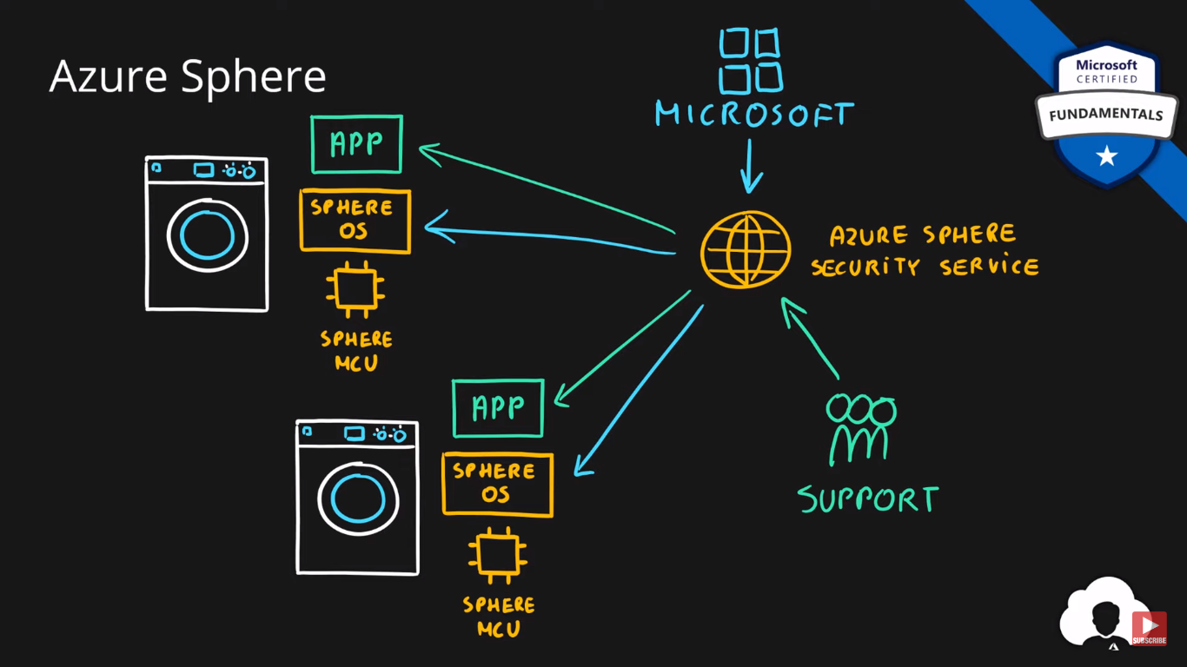

**Steps to connect IOT devices using IOT Hub (azure services)**

1. Create a IOT Hub resource 🡪 go to Devices option on the left column after creation 🡪 add a device
2. Go to the sample simulator for IOT device code link : [Raspberry pi online web simulator](https://azure-samples.github.io/raspberry-pi-web-simulator/)

/*

* IoT Hub Raspberry Pi NodeJS - Microsoft Sample Code - Copyright (c) 2017 - Licensed MIT

*/

**const connectionString = 'HostName=azdemoiot.azure-devices.net;DeviceId=demo-raspberry-pi;SharedAccessKey=mcbE7Ak2+gdXTgp0H4QtJ1mcaRmdNUe43AIoTE8QISk=';**

1. Go to added device in IOT Hub azure 🡪 copy the **primary connection string** 🡪 paste in the code provided in the link as the value of the **connectionString** variable.
2. Run the code

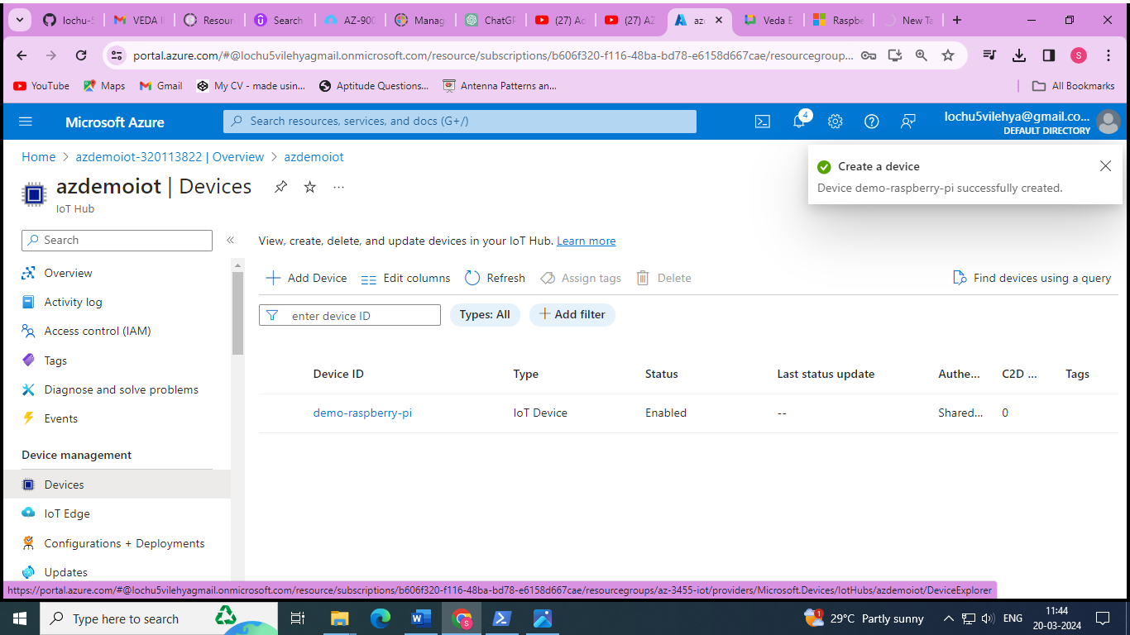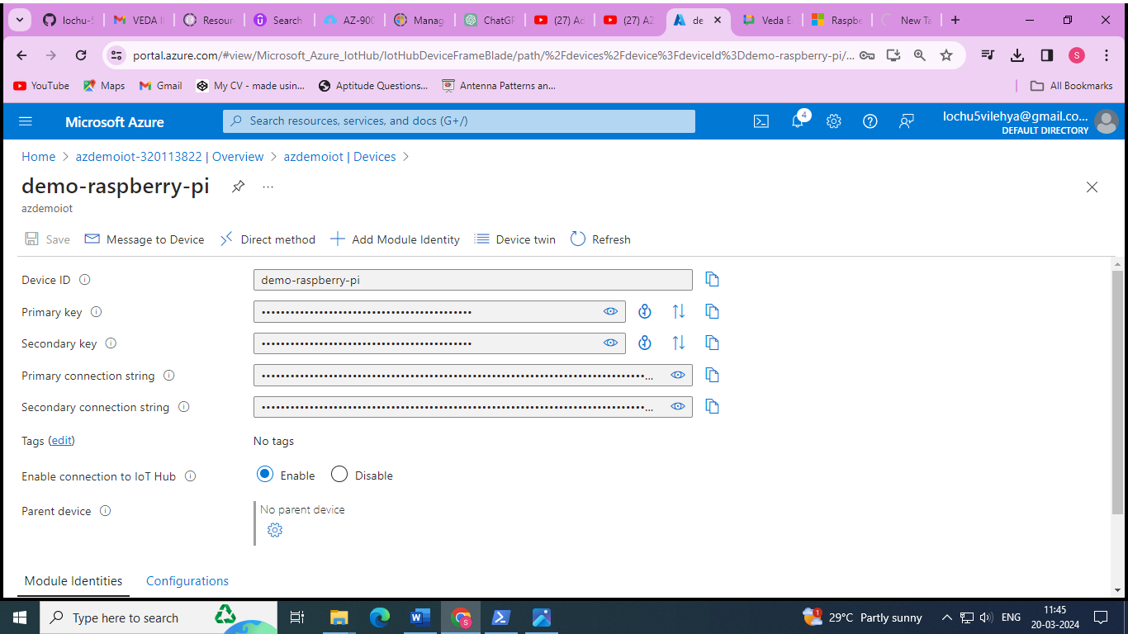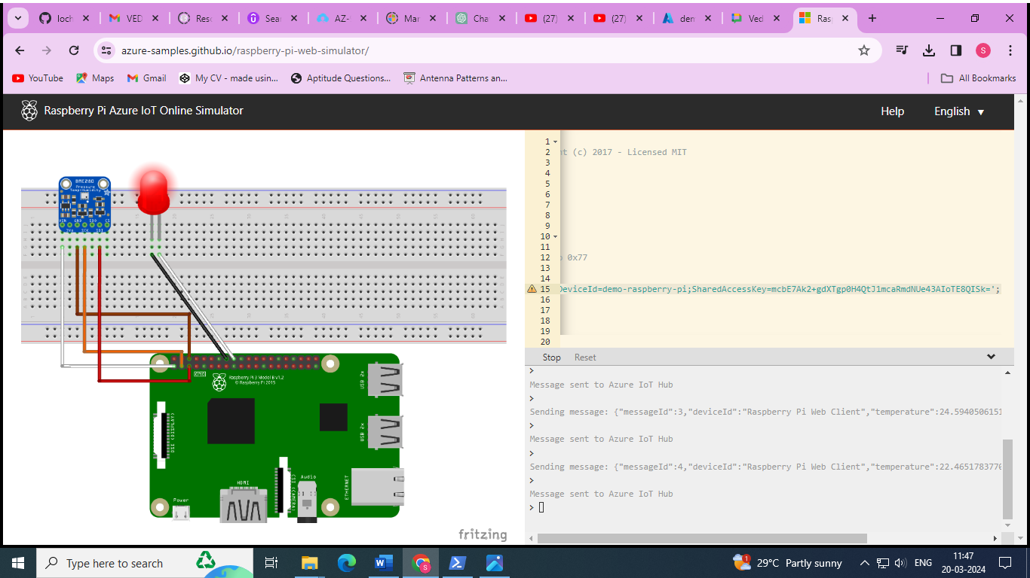

# Azure Big Data & Analytics Services

## **What is Big Data?**

**Big Data** is a field of technology that helps with the **extraction**, **processing** and **analysis** of information that is **too large or complex** to be dealt with by traditional software.

### The three V’s rule

Big data typically has one of the following characteristics

* **Velocity** - how fast the data is coming in or how fast we are processing it
  + Batch
  + Periodic
  + Near Real Time
  + Real Time
* **Volume** - how much data we are processing
  + Megabytes
  + Gigabyte
  + Terabytes
  + Petabytes
* **Variety** - how structured/complex the data is
  + Tables
  + Databases
  + Photo, Audio
  + Video, Social Media

## 

## **Azure Synapse Analytics**

* Big data analytics platform (PaaS)
* Multiple components
  + Spark
  + Synapse SQL
    - SQL pools (dedicated – pay for provisioned performance)
    - SQL on-demand (ad-hoc – pay for TB processed)
  + Synapse Pipelines (Data Factory – ETL)
  + Studio (unified experience)

## 

## **Azure HDInsight**

* Flexible multi-purpose big data platform (PaaS)
* Multiple technologies supported (Hadoop, Spark, Kafka, HBase, Hive, Storm, Machine Learning)

## 

## **Azure Databricks**

* Big data collaboration platform (PaaS)
* Unified workspace for notebook, cluster, data, access management and collaboration
* Based on Apache Spark
* Integrates very well with common Azure data services

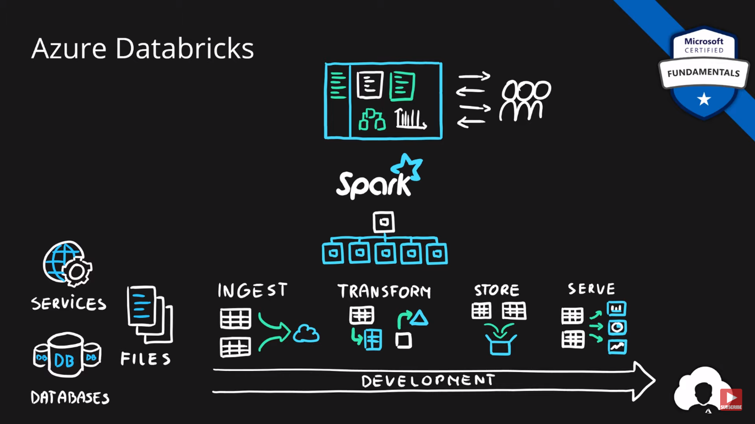

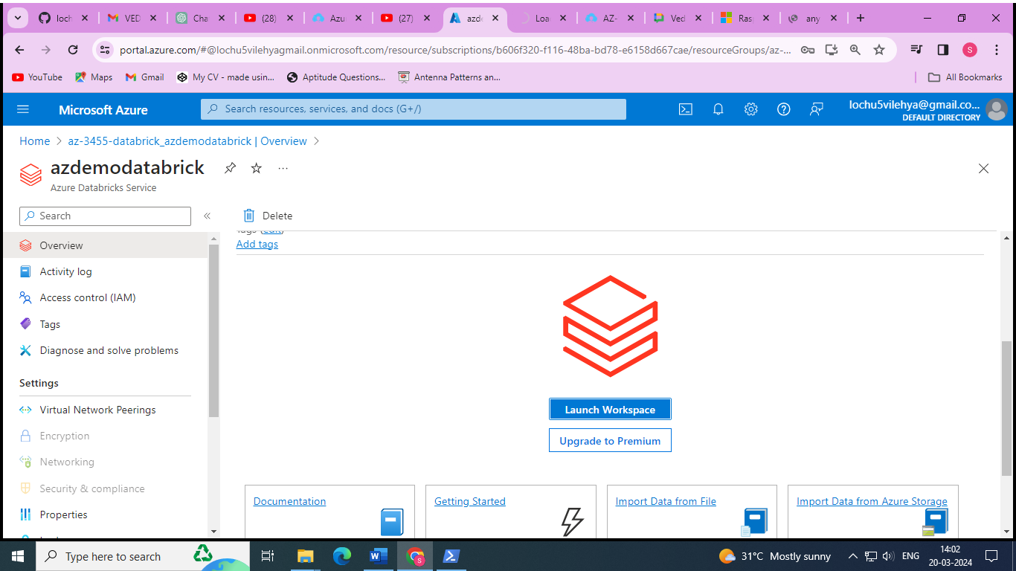

[Azure databricks workspace](https://adb-7008790777661974.14.azuredatabricks.net/?o=7008790777661974&l=en)

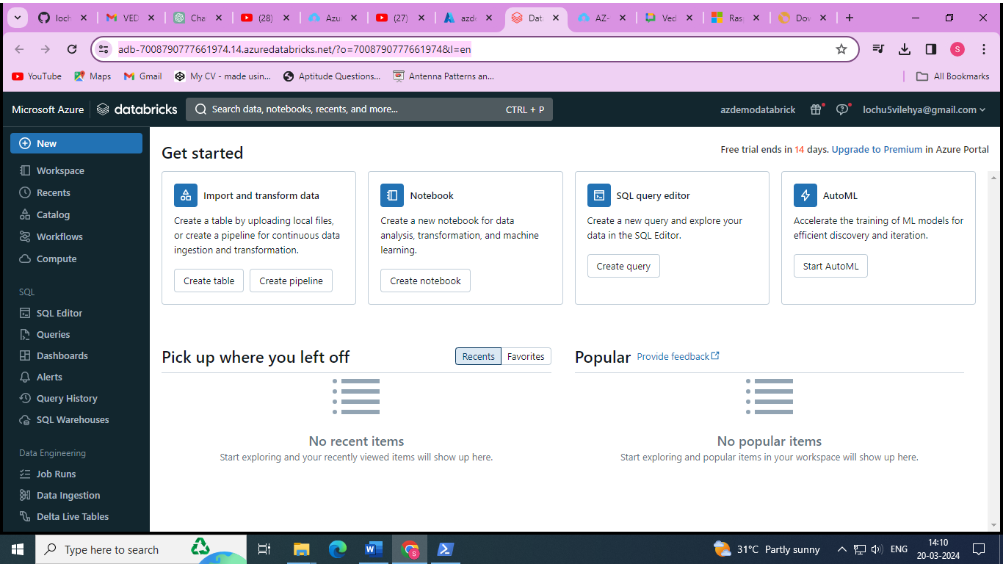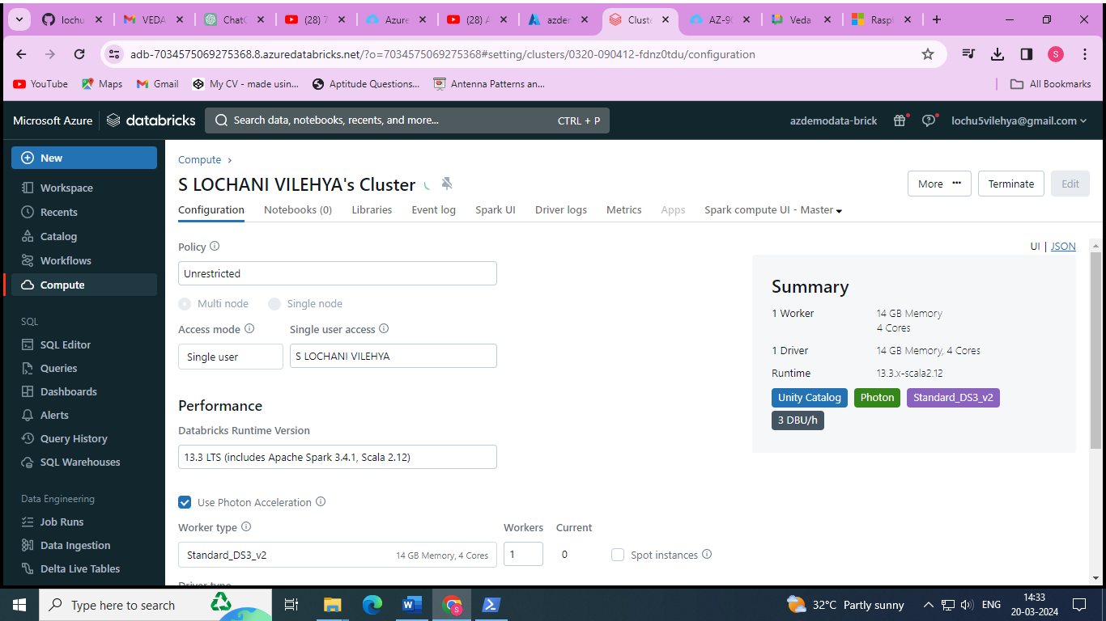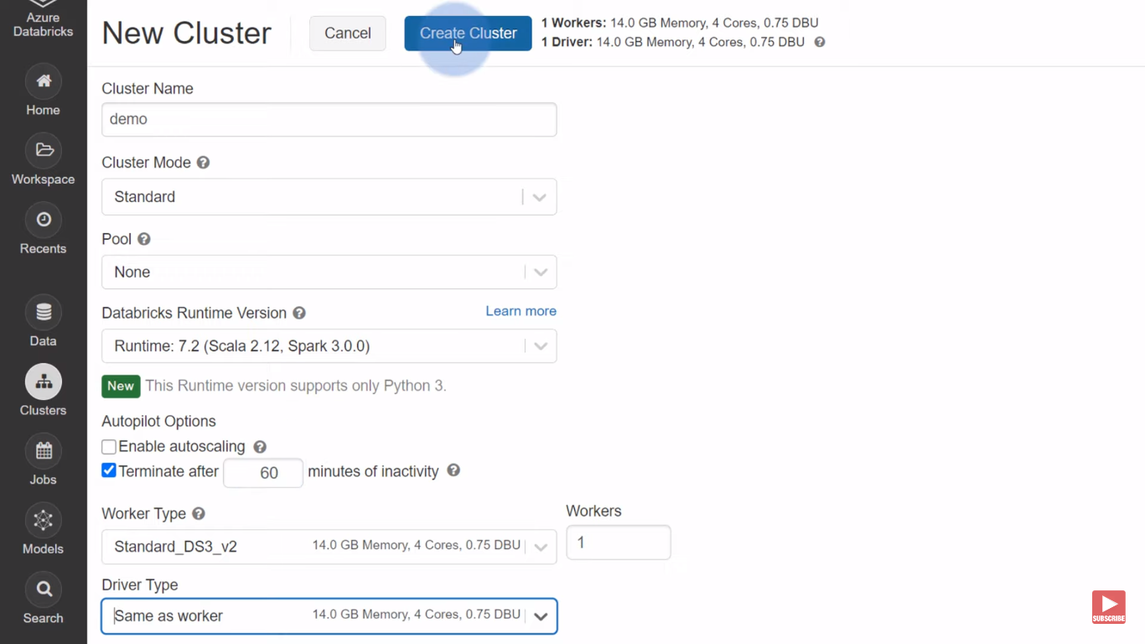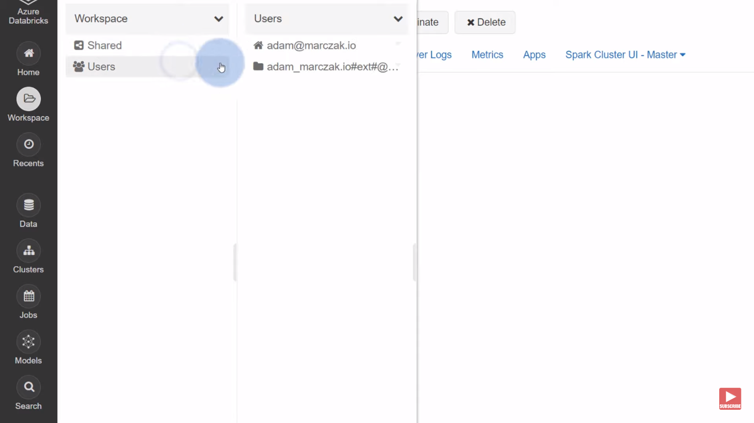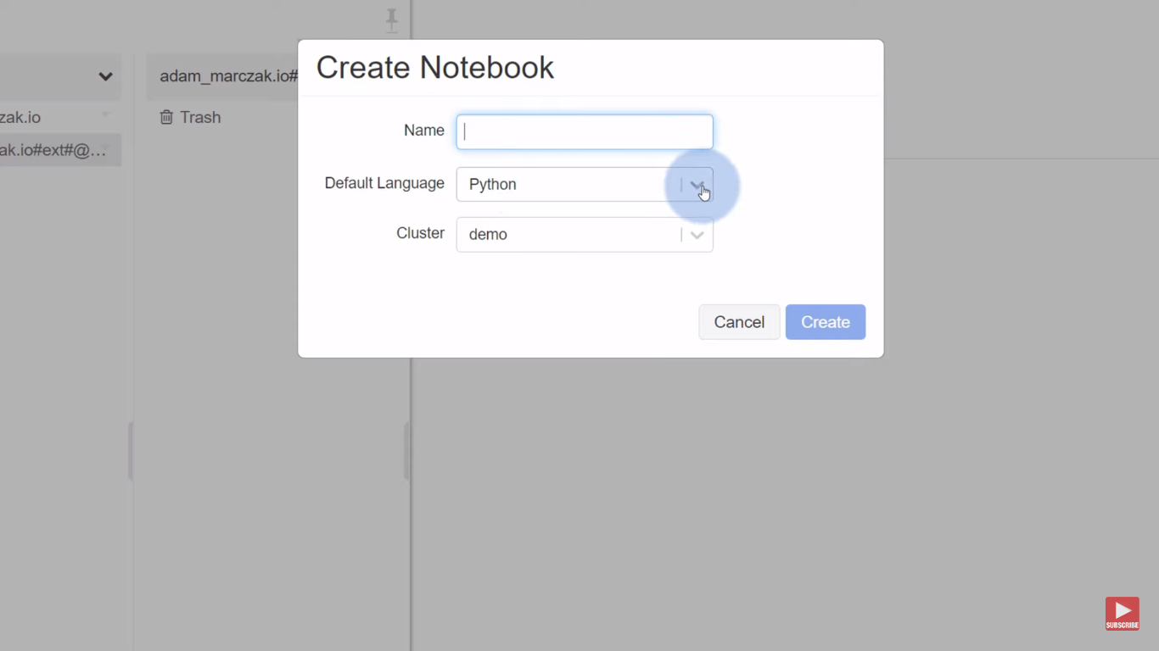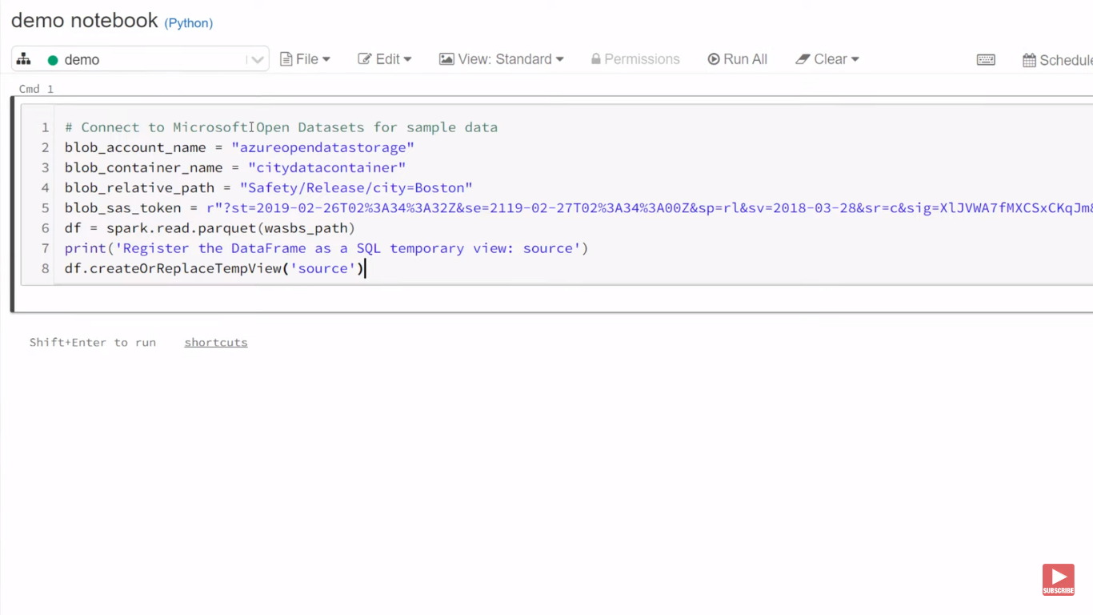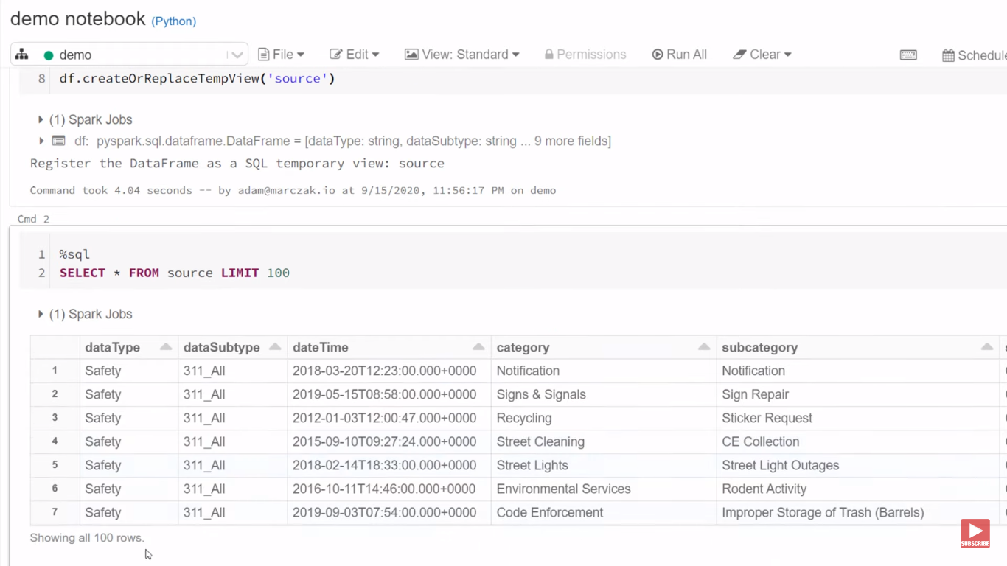

# Azure Artificial Intelligence (AI) Services

### What is Artificial Intelligence?

**Artificial Intelligence** (**AI**) is the simulation of human intelligence & capabilities by computer software.

### What is Machine Learning?

**Machine Learning** is a subcategory of AI where a computer software is “**taught**” to **draw conclusions** and **make predictions** **from data**.

## 

## **Azure Machine Learning**

* Cloud-based platform for creating, managing and publishing machine learning models
* Platform as a Service (PaaS)
* Machine Learning Workspace – top level resource
* Machine Learning Studio – web portal for end-2-end development
* Features
  + Notebooks – using Python and R
  + Automated ML – run multiple algorithms/parameters combinations, choose the best model
  + Designer – graphical interface for no-code development
  + Data & Compute – management of storage and compute resources
  + Pipelines – orchestrate model training, deployment and management tasks

To create a ML azure resource, follow the YouTube link:

[Azure ML services](https://www.youtube.com/watch?v=8aMzR8iaB9s)

[Azure machine learning studio](https://ml.azure.com/?tid=72c8c184-e144-46ac-9337-6f05b0b86092&wsid=/subscriptions/b606f320-f116-48ba-bd78-e6158d667cae/resourcegroups/az-3455-ml/providers/Microsoft.MachineLearningServices/workspaces/azdemoml)

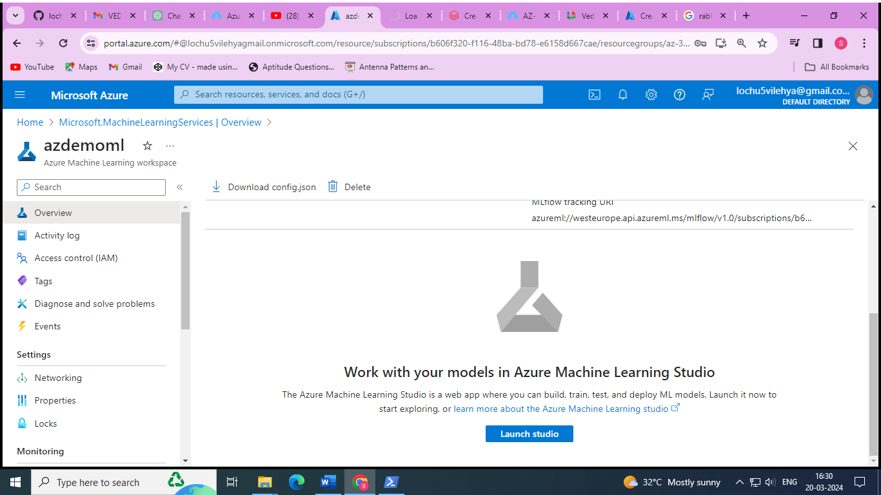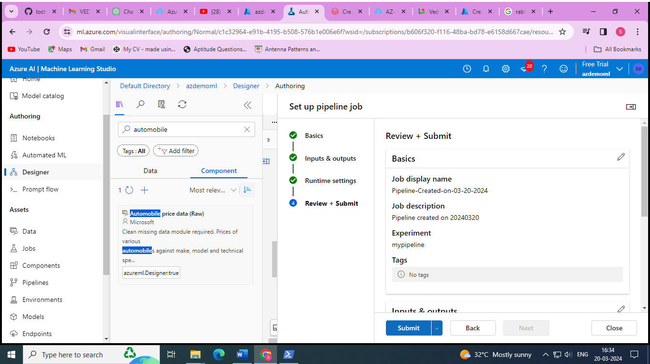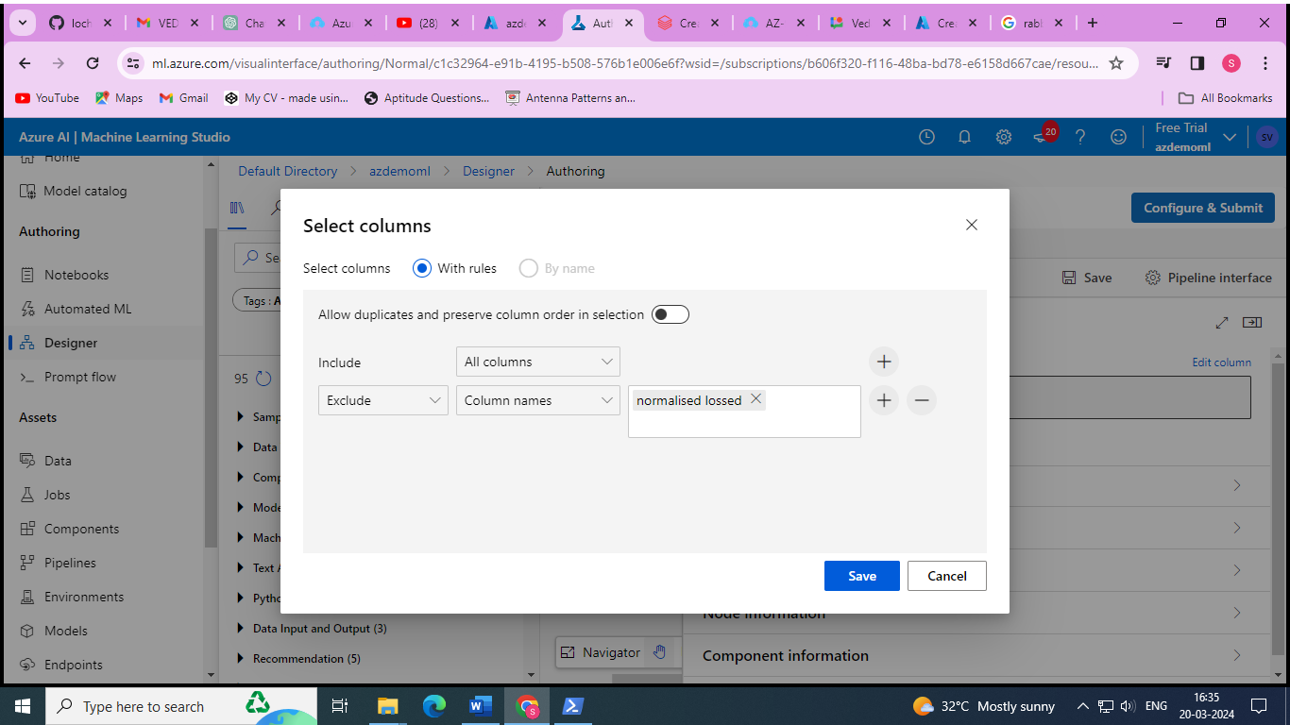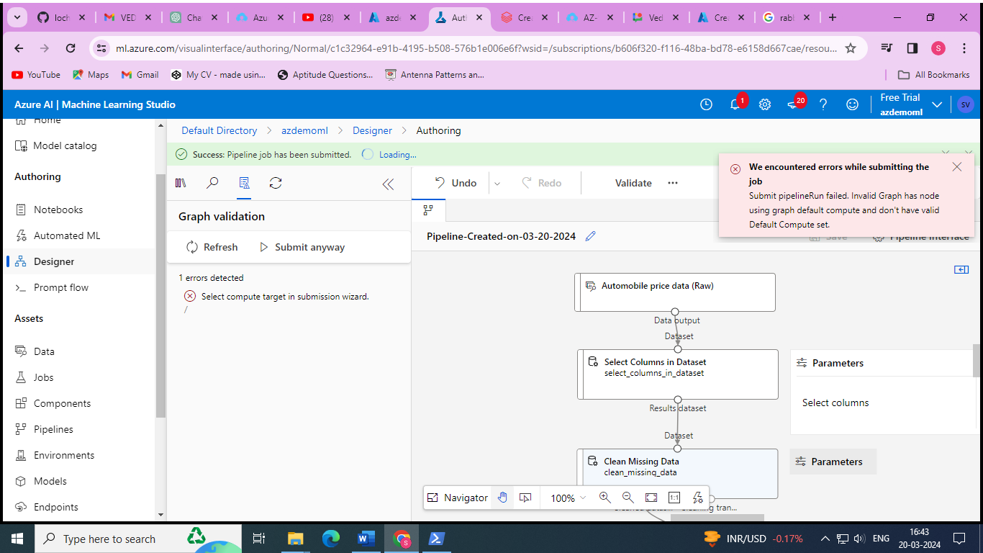

# Azure Serverless Computing Services

### What is Serverless?

**Serverless computing** is cloud-hosted execution environment that allows customers to **run their applications** in the cloud while **completely abstracting underlying infrastructure**.

## **Azure Functions**

* Serverless coding platform (Functions as a Service, FaaS)
* Designed for nano-service architectures and event-based applications
* Scales up and down very quickly
* Highly scalable
* Supports popular languages and frameworks (.NET & .NET Core, Java, Node.js, Python, PowerShell, etc.)

## 

## **Azure Logic Apps**

* Serverless enterprise integration service (PaaS)
* 200+ connectors for popular services
* Designed for orchestration of
  + business processes,
  + integration workflows for applications, data, systems and services
* No-code solution

## 

## **Azure Event Grid**

* Fully managed serverless event routing service
* Uses publish-subscribe model
* Designed for event-based and near-real time applications
* Supports dozens of built-in events from most common Azure services

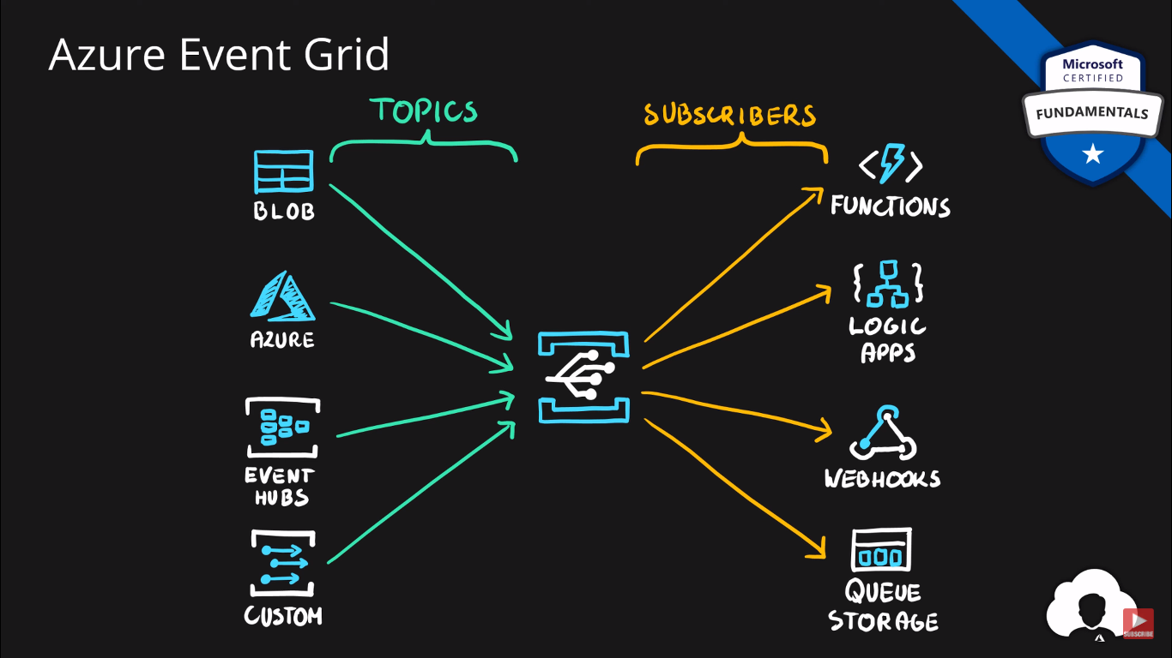

# Azure DevOps Solutions

## **What is DevOps?**

**DevOps** is a set of practices that combine both development (**Dev**) and operations (**Ops**).

DevOps aims to **shorten the development life cycle** by providing **continuous integration** and **delivery** (CI/CD) capabilities while **ensuring high quality** of deliverables.

## 

## **Azure DevOps**

* **Collection of services** for building solutions using DevOps practices
* Services included
  + **Boards** – tracking work
  + **Pipelines** – building CI/CD workflows (build, test and deploy apps)
  + **Repos** – code collaboration and versioning with Git
  + **Test Plans** – manual and exploratory testing
  + **Artifacts** – manage project deliverables
* Extensible with **Marketplace** – over 1000 of available apps
* Evolved from **TFS** (Team Foundation Server), through **VSTS** (Visual Studio Team Services)

## 

## **Azure DevTest Labs**

* Service for creation of **sandbox environments** for developers/testers (PaaS)
* Quick setup of **self-managed virtual machines**
* **Preconfigured templates** for VMs
* Plenty of additional **artifacts** (tools, apps, custom actions)
* Lab **policies** (quotas, sizes, auto-shutdowns)
* **Share** and **automate** labs via custom images
* Premade plugins/API/tools for **CI/CD pipeline automation**

Create a resource in the DevTest lab 🡪 add a base (VM) 🡪 add the required artifacts (7-zip,VS code,git) 🡪 run the VM 🡪 after creating click on it 🡪 connect 🡪 it opens the new pop-up windows security for new windows 🡪 Enter the password 🡪 it creates the vm with required artifacts.

